**PROJECT**

**BIG DATA ANALYSIS**

**To: Mr. Deepak Kumar Sharma Sir**

**By: Kshitiz Sharan**

**Roll Number: R172218151**

**Sap ID: 500070933**

TABLE OF CONTENT

1. Project Description
2. Environment Setup
3. Data Set / Input Files
4. Schema of Important Tables
5. Problem Statements
6. Project Assignment Modules
7. Pacing the given datasets in HDFS
8. Create Directory in HDFS
9. Placing the Data in the HDFS directory
10. Implementation in HIVE
11. Creating Hive Database
12. Creating and Loading the HIVE tables with the given Database
13. Problem 1
14. HIVE Query
15. Output
16. Explanation
17. Problem 2

i) HIVE Query

ii) Output

iii) Explanation

1. Problem 3

i) HIVE Query

ii) Output

iii) Explanation

1. Problem 4

i) HIVE Query

ii) Output

iii) Explanation

1. Problem 5

i) HIVE Query

ii) Output

iii) Explanation

1. Problem 6

i) HIVE Query

ii) Output

iii) Explanation

1. Problem 7

i) HIVE Query

ii) Output

iii) Explanation

1. Problem 8

i) HIVE Query

ii) Output

iii) Explanation

1. Problem 9

i) HIVE Query

ii) Output

iii) Explanation

1. Problem 10

i) HIVE Query

ii) Output

iii) Explanation

PROJECT DESCRIPTION

The project aims to display the effects of CORONAVIRUS on the mankind using HIVE. In other word it shows how mankind fights the pandemic that has impacted millions of people.

Assuming each dataset provided by the authorities is in CSV file format. And all the analysis is done using these csv files provided by the authorities to the public domain. All the problems follow the chronology as per my best knowledge.

ENVIRONMENT SETUP

Cloudera Version :- cloudera-quickstart-vm-5.13.0-0-virtualbox

Hadoop Version :- Hadoop 2.6.0-cdh5.13.0

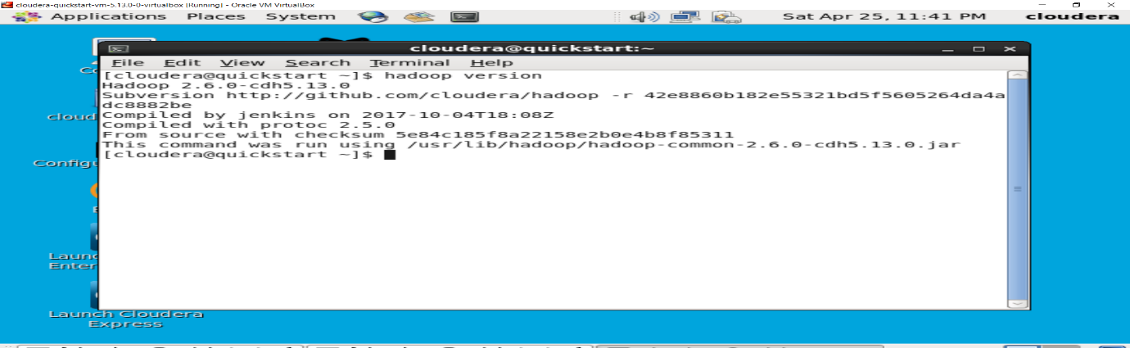

Hive Version :- Hive 1.1.0-cdh5.13.0

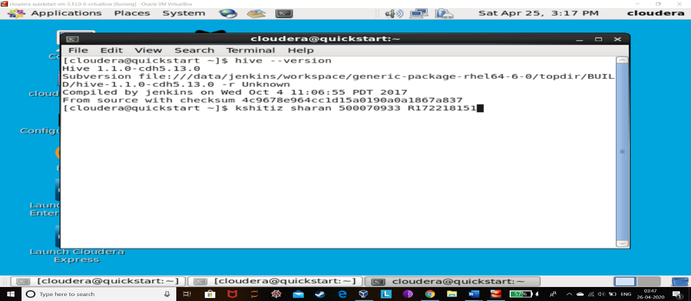

DATA SET / INPUT FILES

Most of my dataset is from Kaggle.

1. <https://www.kaggle.com/sudalairajkumar/novel-corona-virus-2019-dataset>
2. <https://www.kaggle.com/sudalairajkumar/covid19-in-india>
3. <https://www.kaggle.com/webaccess/india-primary-health-care-data>

SCHEMA of IMPORTANT TABLES

1. Table Name with Schema:
2. Age_Group_Details

SerialNumber integer

Age_Group string

Total_cases integer

Percentage float

1. Assistant_Female_Doc

SerialNumber integer

State string

Required integer

Sanctioned integer

InPosition integer

1. Assistant_Male_Doc

SerialNumber integer

State string

Required integer

Sanctioned integer

InPosition integer

1. Covid_19_India

SerialNumber integer

Date_of_Observation date

State_UnionTerritory string

Confirmed_Indian_National integer

Confirmed_Foreign_National integer

Confirmed integer

Cured integer

Deaths integer

1. Covid_Analysis

serialnumber int

observation_date date

state string

country string

confirmed_cases int

deaths int

recovered int

1. Doc_PHCS

serialnumber int

state string

required int

sanctioned int

inposition int

1. Global_Data_Covid19

date_of_report date

day int

month int

year int

cases int

deaths int

countries string

geoid string

countrycode string

population_data int

continent string

1. Hospital_Beds_in_India

serialnumber int

state_ut string

numprimaryhealthcenters_hmis int

numcommunityhealthcenters_hmis int

numsubdistricthospitals_hmis int

numdistricthospitals_hmis int

totalpublichealthfacilities_hmis int

numpublicbeds_hmis int

numruralhospital_nhp18 int

numruralbeds_nhp18 int

numurbanhospitals_nhp18 int

numurbanbeds_nhp18 int

1. ICMR_Active_Testing_Labs

lab string

city string

state string

type string

1. ICMR_Testing_Details

sno bigint

datetime date

totalsamplestested bigint

totalindividualstested bigint

totalpositivecases bigint

1. Nursing_Staff

serialnumber int

state string

required int

sanctioned int

inposition int

1. Pharmacists

serialnumber int

state string

required int

sanctioned int

inposition int

1. Physician

serialnumber int

state string

required int

sanctioned int

inposition int

1. Population_India

serialnumber int

state_ut string

population bigint

rural_population bigint

urban_population bigint

area string

density string

gender_ratio bigint

1. Rate_of_Spread

rate int

1. Statewise_Testing_details

date date

state string

total_samples int

result_negative int

result_positive int

1. Surgeons

serialnumber int

state string

required int

sanctioned int

inposition int

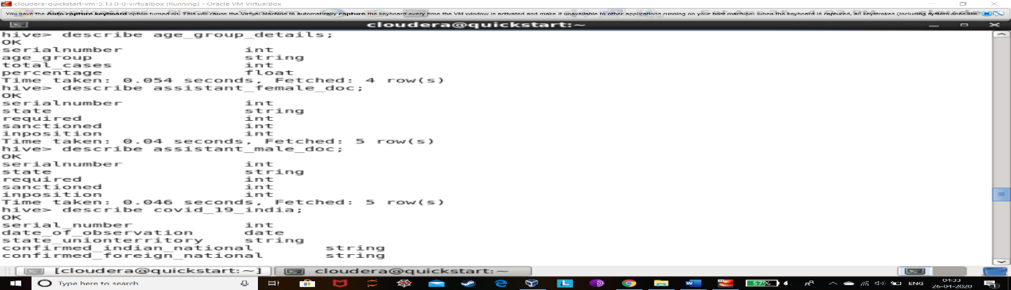  
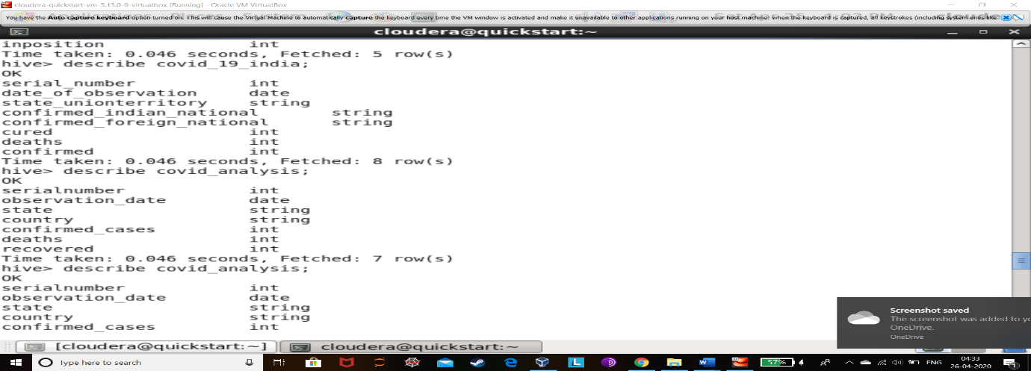 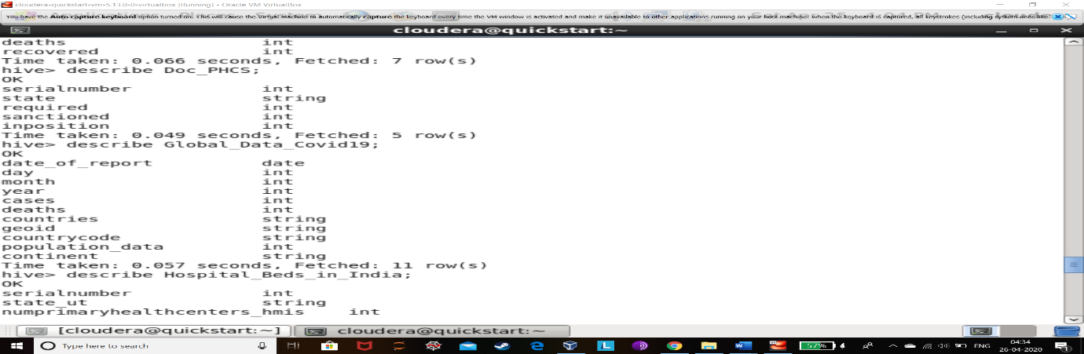 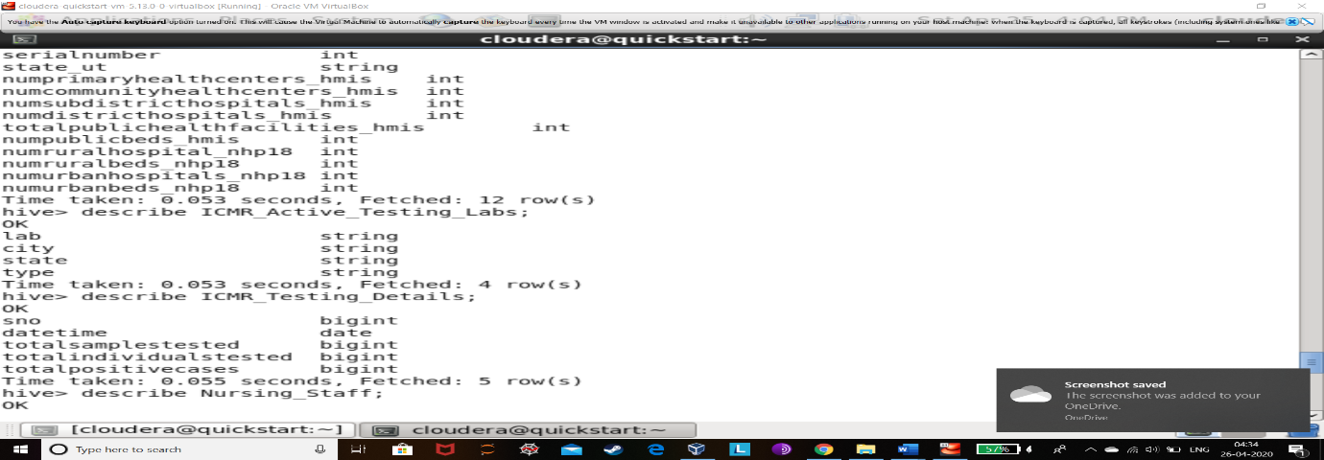

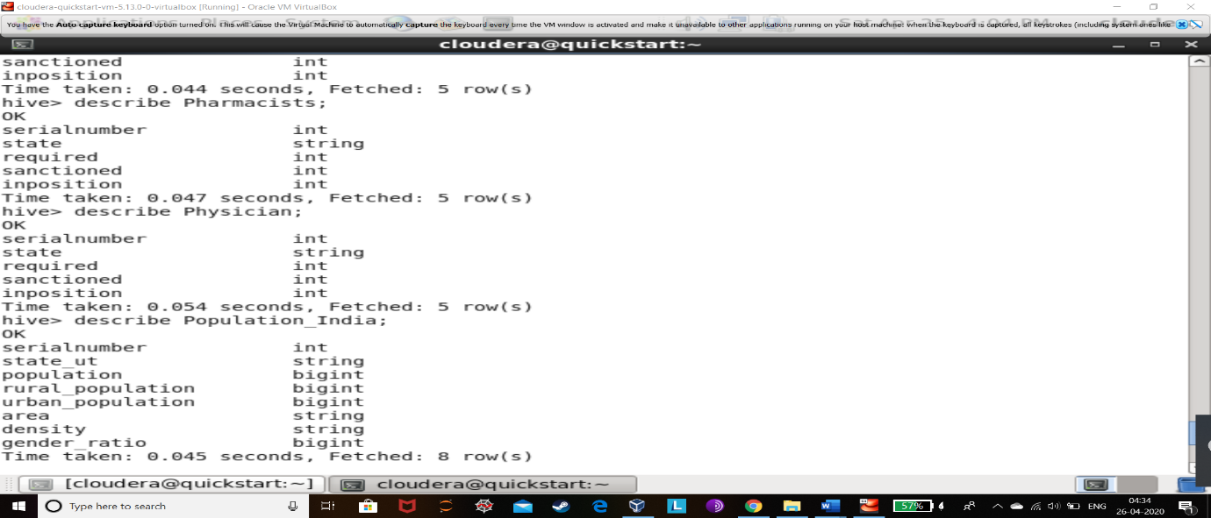

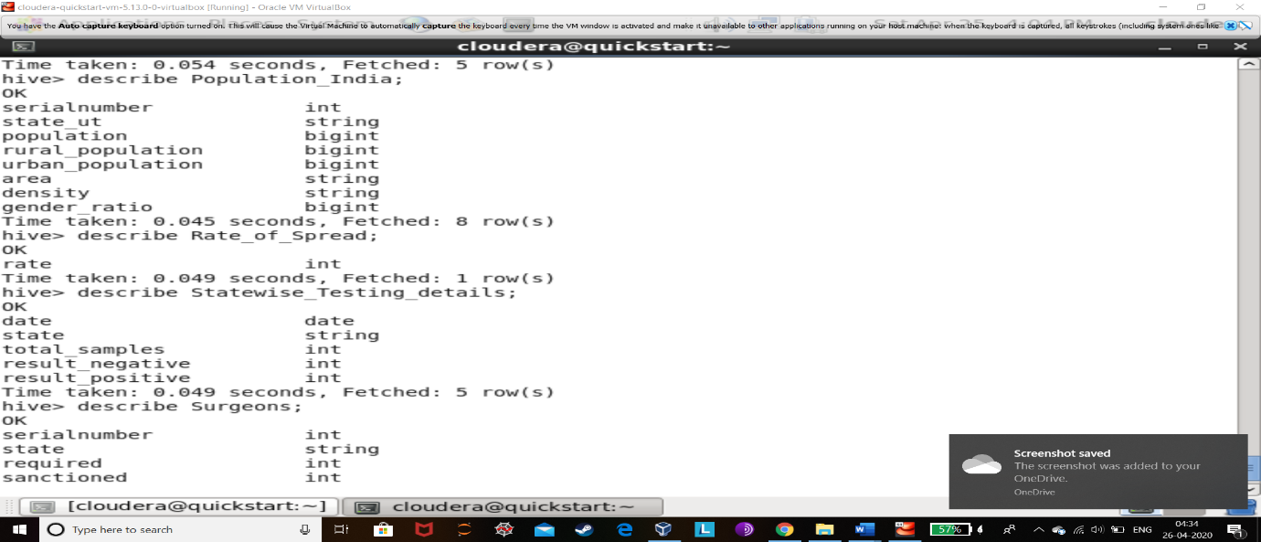

PROBLEM STATEMENTS

1. How many beds in hospitals are going to be required internationally approximately?
2. How many beds in hospitals are going to be required in India approximately?
3. How many total beds are present in India to accommodate going patient number?
4. How many Testing Laboratories are present in India other than Hospitals to test blood samples on large scale and to conduct research for finding a cure or vaccine for coronavirus?
5. How many TEST KITS are required in the worst-case scenario by India to make sure who is corona positive or negative?
6. Who is the maximum coronavirus effected people in India?
7. How many MASKS and HAND GLOVES are needed to be imported or produce in India?
8. What is the increase in rate of corona spread in India?
9. How big is India’s MEDICAL TEAM to tackle the pandemic?
10. How to make sure that coronavirus does not spread further in the people?

PLACE THE GIVEN DATASET IN HDFS

Create Directory in HDFS

1. The below code is for creating directory called “kshitiz_500070933_projecct1

*hadoop fs -mkdir /user/hive/kshitiz_500070933_project1*



1. Placing the input files in the HDFS directory

Copying all the given dataset from the local to the HDFS directory in a separate directory.

1. *hadoop fs -copyFromLocal covid_19_data.csv /user/hive/kshitiz_500070933_project1/covid_19_data.csv*
2. *hadoop fs -copyFromLocal AgeGroupDetails.csv /user/hive/kshitiz_500070933_project1/**AgeGroupDetails.csv*
3. *hadoop fs -copyFromLocal covid_19_india_updated.csv /user/hive/kshitiz_500070933_project1/covid_19_india_updated.csv*
4. *hadoop fs -copyFromLocal download.csv /user/hive/kshitiz_500070933_project1/download.csv*
5. *hadoop fs -copyFromLocal HospitalBedsIndia_updated.csv /user/hive/kshitiz_500070933_project1/HospitalBedsIndia_updated.csv*
6. *hadoop fs -copyFromLocal population_india_census2011.csv /user/hive/kshitiz_500070933_project1/population_india_census2011.csv*
7. *hadoop fs -copyFromLocal StatewiseTestingDetails_updated.csv /user/hive/kshitiz_500070933_project1/StatewiseTestingDetails_updated.csv*
8. *hadoop fs -copyFromLocal* *ICMRTestingLabs_updated1.csv /user/hive/kshitiz_500070933_project1/ICMRTestingLabs_updated1.csv*
9. *hadoop fs -copyFromLocal ICMRTestingDetails_updated.csv /user/hive/kshitiz_500070933_project1/ICMRTestingDetails_updated.csv*
10. *hadoop fs -copyFromLocal allo-doc-PHCS_2017_updated.csv /user/hive/kshitiz_500070933_project1/**allo-doc-PHCS_2017_updated.csv*
11. *hadoop fs -copyFromLocal assistant-female-PHCS_2017_updated.csv /user/hive/kshitiz_500070933_project1/assistant-female-PHCS_2017_updated.csv*
12. *hadoop fs -copyFromLocal assistant-male-PHCS_2017_updated.csv /user/hive/kshitiz_500070933_project1/assistant-male-PHCS_2017_updated.csv*
13. *hadoop fs -copyFromLocal nursing-staff-PHCS-CHCS_2017_updated.csv /user/hive/kshitiz_500070933_project1/nursing-staff-PHCS-CHCS_2017_updated.csv*
14. *hadoop fs -copyFromLocal pharmacists-PHCS-CHCS_2017_updated.csv /user/hive/kshitiz_500070933_project1/pharmacists-PHCS-CHCS_2017_updated.csv*
15. *hadoop fs -copyFromLocal* *physician-CHCS_2017_updated.csv /user/hive/kshitiz_500070933_project1/physician-CHCS_2017_updated.csv*
16. *hadoop fs -copyFromLocal surgeons-CHCS_2017_updated.csv /user/hive/kshitiz_500070933_project1/surgeons-CHCS_2017_updated.csv*

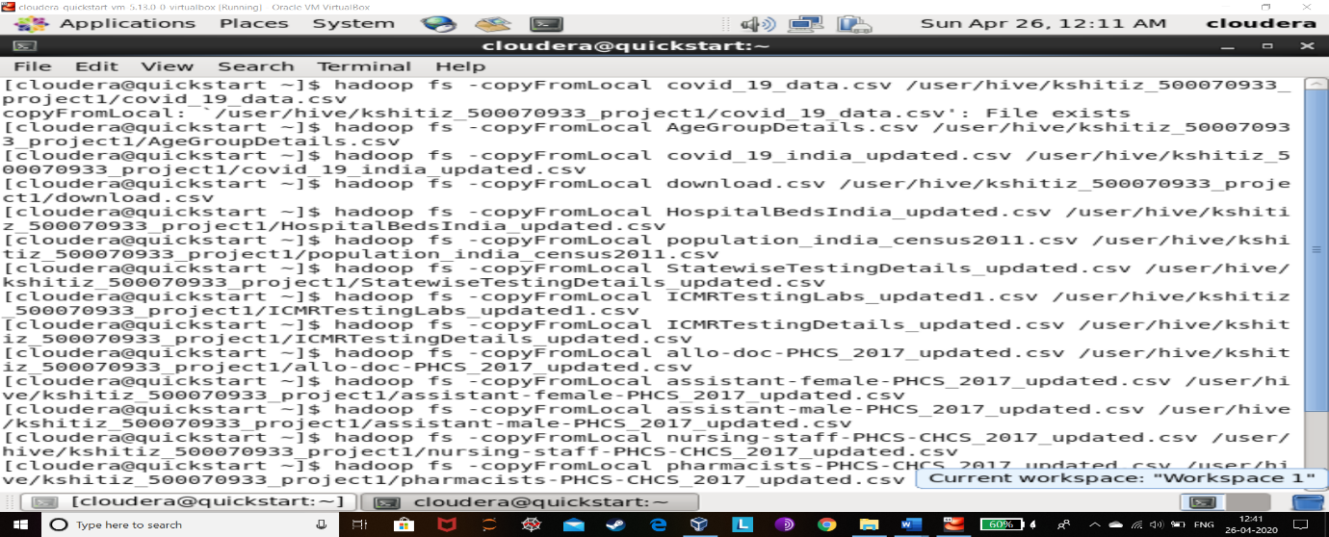

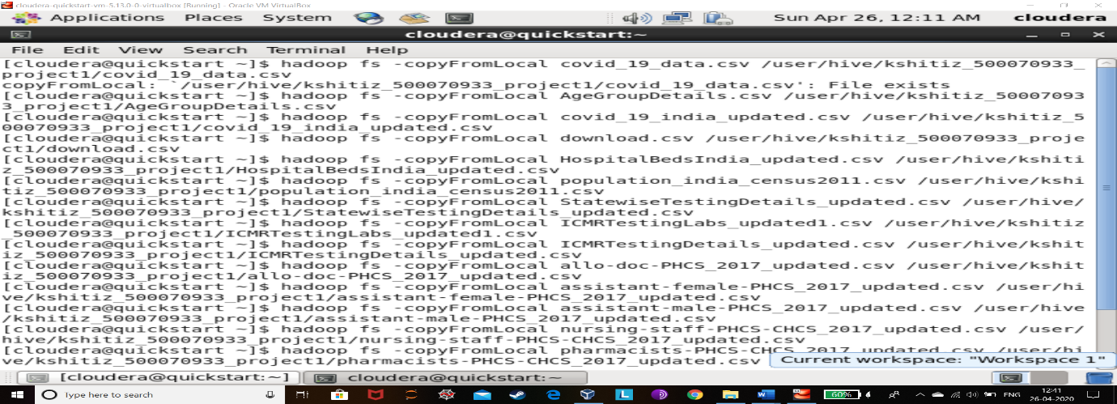

1. Check whether the files got placed in the HDFS.
2. *hdfs dfs -ls /user/hive/kshitiz_500070933_project1/covid_19_data.csv*
3. *hdfs dfs -ls /user/hive/kshitiz_500070933_project1/ AgeGroupDetails.csv*
4. *hdfs dfs -ls /user/hive/kshitiz_500070933_project1/ covid_19_india_updated.csv*
5. *hdfs dfs -ls /user/hive/kshitiz_500070933_project1/ download.csv*
6. *hdfs dfs -ls /user/hive/kshitiz_500070933_project1/ HospitalBedsIndia_updated.csv*
7. *hdfs dfs -ls /user/hive/kshitiz_500070933_project1/ population_india_census2011.csv*
8. *hdfs dfs -ls /user/hive/kshitiz_500070933_project1/ StatewiseTestingDetails_updated.csv*
9. *hdfs dfs -ls /user/hive/kshitiz_500070933_project1/ ICMRTestingLabs_updated1.csv*
10. *hdfs dfs -ls /user/hive/kshitiz_500070933_project1/ ICMRTestingDetails_updated.csv*
11. *hdfs dfs -ls /user/hive/kshitiz_500070933_project1/allo-doc-PHCS_2017_updated.csv*
12. *hdfs dfs -ls /user/hive/kshitiz_500070933_project1/assistant-female-PHCS_2017_updated.csv*
13. *hdfs dfs -ls /user/hive/kshitiz_500070933_project1/ assistant-male-PHCS_2017_updated.csv*
14. *hdfs dfs -ls /user/hive/kshitiz_500070933_project1/nursing-staff-PHCS-CHCS_2017_updated.csv*
15. *hdfs dfs -ls /user/hive/kshitiz_500070933_project1/ pharmacists-PHCS-CHCS_2017_updated.csv*
16. *hdfs dfs -ls /user/hive/kshitiz_500070933_project1/ physician-CHCS_2017_updated.csv*
17. *hdfs dfs -ls /user/hive/kshitiz_500070933_project1/ surgeons-CHCS_2017_updated.csv*

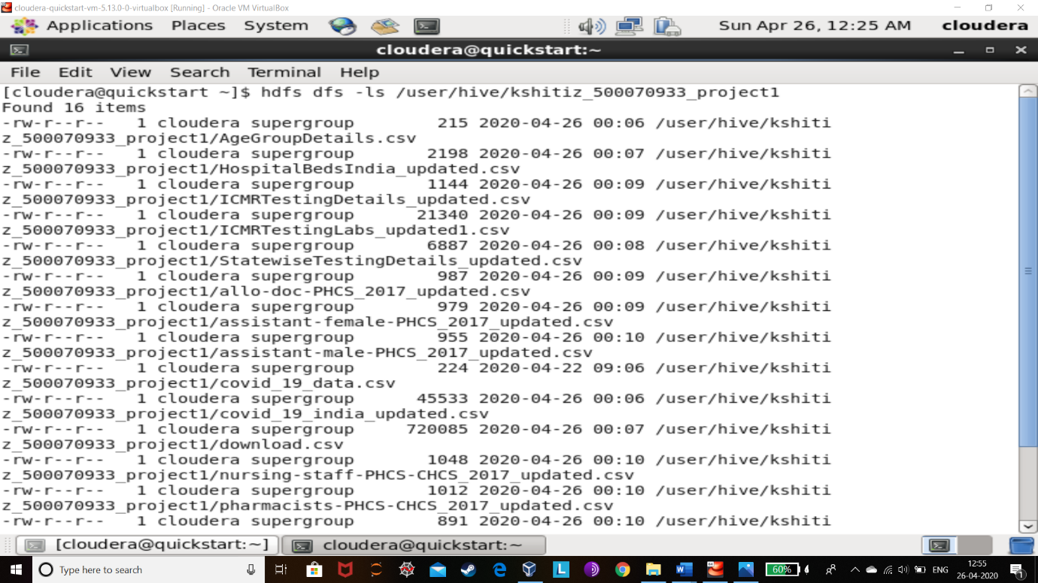 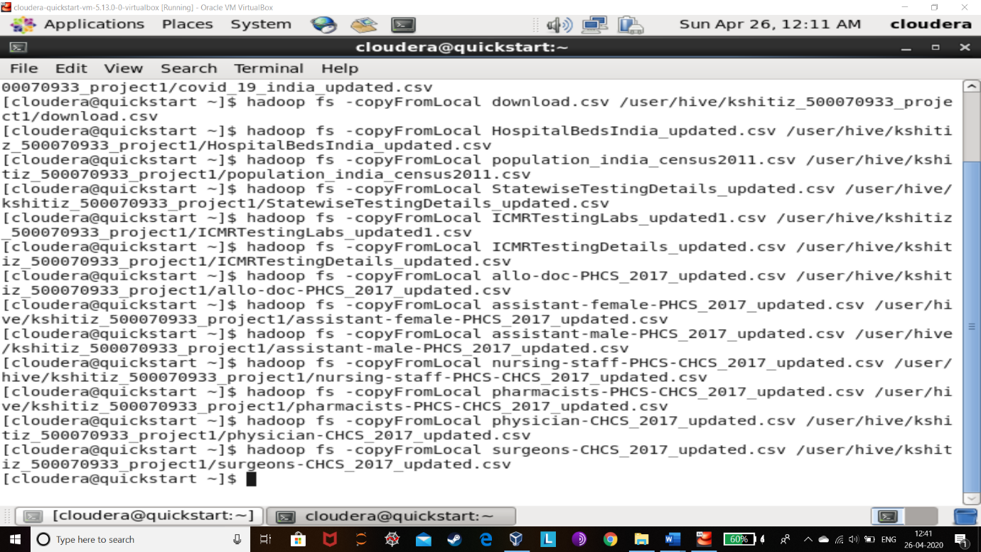

IMPLEMENTATION IN HIVE

1. Creating HIVE Database

*create database if not exits kshitizproject1 with dbproperties(‘creator’=’500070933’);*

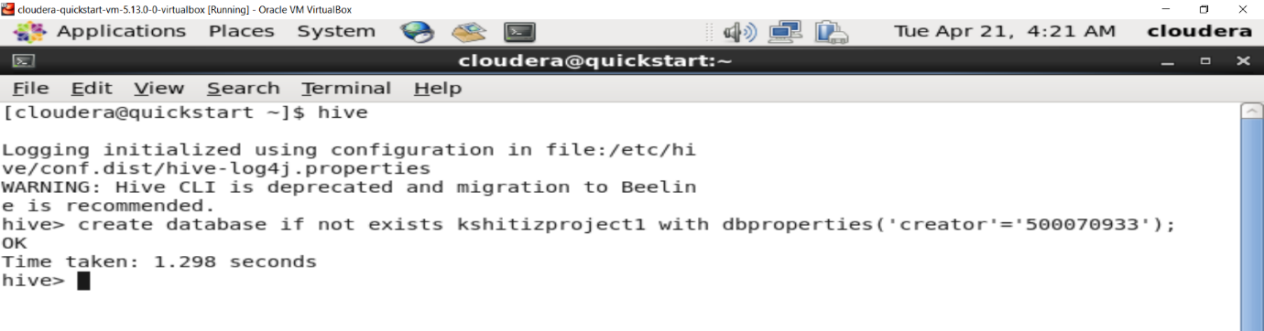

*Show databases;*

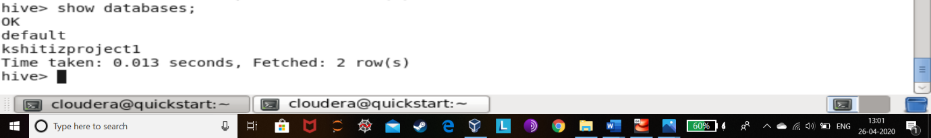

1. Creating & Loading the HIVE tables with the given datasets
2. *create table if not exists age_group_details*

*(SerialNumber int,Age_Group string,Total_cases int,Percentag float)*

*row format delimited fields terminated by ','*

*tblproperties("skip.header.line.count"="1");*

*load data inpath '/user/hive/kshitiz_500070933_project1/AgeGroupDetails.csv' into table age_group_details;*

1. *create table if not exists* *assistant_female_doc*

*(SerialNumber int,State string,Required int,Sanctioned int,InPosition int)*

*row format delimited fields terminated by ','*

*tblproperties("skip.header.line.count"="1");*

*load data inpath '/user/hive/kshitiz_500070933_project1/assistant-female-*

*PHCS_2017_updated.csv' into table assistant_female_doc;*

1. *create table if not exists assistant_male_doc*

*(SerialNumber int,Age_Group string,Total_cases int,Percentag float)*

*row format delimited fields terminated by ','*

*tblproperties("skip.header.line.count"="1");*

*load data inpath '/user/hive/kshitiz_500070933_project1/assistant-male-PHCS_2017_updated.csv' into table assistant_male_doc;*

1. *create table if not exists covid_19_india*

*(SerialNumber int,Date_of_Observation date,State_UnionTerritory string,Confirmed_Indian_National int,Confirmed_Foreign_National int,Cured int,Deaths int, Confirmed int)*

*row format delimited fields terminated by ','*

*tblproperties("skip.header.line.count"="1");*

*load data inpath '/user/hive/kshitiz_500070933_project1/covid_19_india_updated.csv' into table covid_19_india;*

1. *create table if not exists covid_analysis*

*(Serialnumber int,observation_date date,State string,country string,confirmed_cases int,deaths int,recovered int)*

*row format delimited fields terminated by ','*

*tblproperties("skip.header.line.count"="1");*

*load data inpath '/user/hive/kshitiz_500070933_project1/covid_19_data.csv' into table covid_analysis;*

1. *create table if not exists doc_phcs*

*(serialnumber int,state string,required int,sanctioned int,inposition int)*

*row format delimited fields terminated by ','*

*tblproperties("skip.header.line.count"="1");*

*load data inpath '/user/hive/kshitiz_500070933_project1/allo-doc-PHCS_2017_updated.csv' into table doc_phcs;*

1. *create table if not exists nursing_staff*

*(serialnumber int,state string,required int,sanctioned int,inposition int)*

*row format delimited fields terminated by ','*

*tblproperties("skip.header.line.count"="1");*

*load data inpath '/user/hive/kshitiz_500070933_project1/nursing-staff-PHCS-CHCS_2017_updated.csv' into table nursing_staff;*

1. *create table if not exists pharmacists*

*(serialnumber int,state string,required int,sanctioned int,inposition int)*

*row format delimited fields terminated by ','*

*tblproperties("skip.header.line.count"="1");*

*load data inpath '/user/hive/kshitiz_500070933_project1/pharmacists-PHCS-CHCS_2017_updated.csv' into table pharmacists;*

1. *create table if not exists physician*

*(serialnumber int,state string,required int,sanctioned int,inposition int)*

*row format delimited fields terminated by ','*

*tblproperties("skip.header.line.count"="1");*

*load data inpath '/user/hive/kshitiz_500070933_project1/physician-CHCS_2017_updated.csv' into table physician;*

1. *create table if not exists surgeons*

*(serialnumber int,state string,required int,sanctioned int,inposition int)*

*row format delimited fields terminated by ','*

*tblproperties("skip.header.line.count"="1");*

*load data inpath '/user/hive/kshitiz_500070933_project1/surgeons-CHCS_2017_updated.csv' into table surgeons;*

1. *create table if not exists global_data_covid19*

*(date_of_report date,day int,month int,year int,cases int,deaths int,countries string,geoid string,countrycode string,population_data int,continent string)*

*row format delimited fields terminated by ','*

*tblproperties("skip.header.line.count"="1");*

*load data inpath '/user/hive/kshitiz_500070933_project1/download.csv' into table global_data_covid19;*

1. *create table if not exists hospital_beds_in_india*

*(serialnumber int,state_ut string, numprimaryhealthcenters_hmis int,numcommunityhealthcenters_hmis int,numsubdistricthospitals_hmis int,numdistricthospitals_hmis int,totalpublichealthfacilities_hmis int,numpublicbeds_hmis int,numruralhospital_nhp18 int,numruralbeds_nhp18 int,numurbanhospitals_nhp18 int,numurbanbeds_nhp18 int)*

*row format delimited fields terminated by ','*

*tblproperties("skip.header.line.count"="1");*

*load data inpath '/user/hive/kshitiz_500070933_project1/HospitalBedsIndia_updated.csv' into table hospital_beds_in_india;*

1. *create table if not exists icmr_active_testing_labs*

*(Lab string,city string,state string,type string)*

*row format delimited fields terminated by ','*

*tblproperties("skip.header.line.count"="1");*

*load data inpath '/user/hive/kshitiz_500070933_project1/ICMRTestingLabs_updated1.csv' into table icmr_active_testing_labs;*

1. *create table if not exists icmr_testing_details*

*(sno bigint,datetime date,totalsamplestested bigint,totalindividualstested bigint,totalpositivecases bigint)*

*row format delimited fields terminated by ','*

*tblproperties("skip.header.line.count"="1");*

*load data inpath '/user/hive/kshitiz_500070933_project1/ICMRTestingDetails_updated.csv' into table icmr_testing_details;*

1. *create table if not exists population_india*

*(serialnumber int,state_ut string,population bigint,rural_population bigint,urban_population bigint,area string,density string,gender_ratio bigint)*

*row format delimited fields terminated by ','*

*tblproperties("skip.header.line.count"="1");*

*load data inpath '/user/hive/kshitiz_500070933_project1/population_india_census2011.csv' into table population_india;*

1. *create table if not exists statewise_testing_details*

*(date date,state string,total_samples int,result_negative int,result_positive int)*

*row format delimited fields terminated by ','*

*tblproperties("skip.header.line.count"="1");*

*load data inpath '/user/hive/kshitiz_500070933_project1/StatewiseTestingDetails_updated.csv' into table statewise_testing_details;*

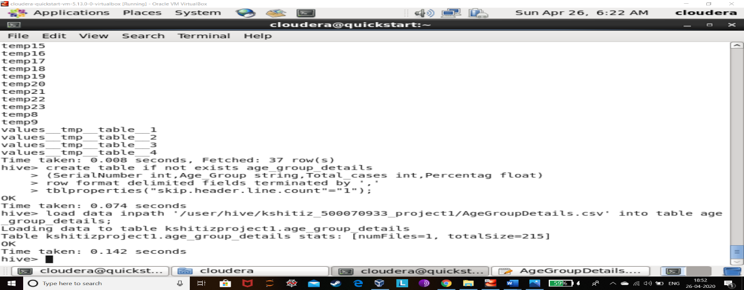

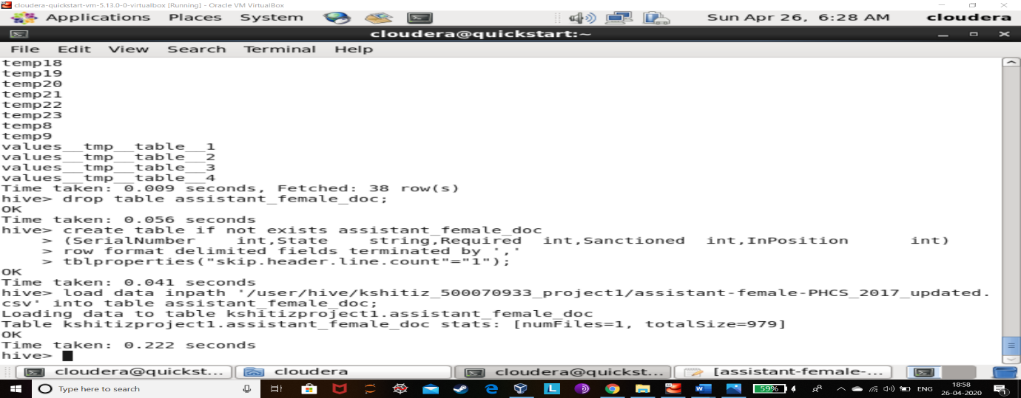

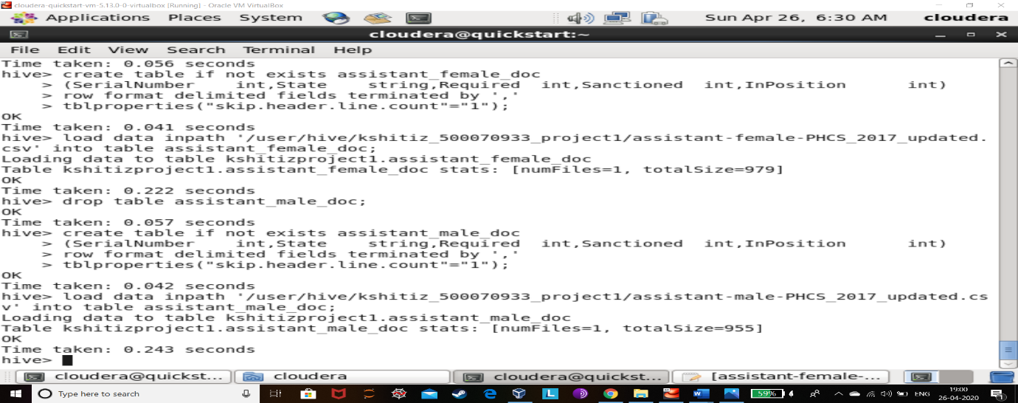

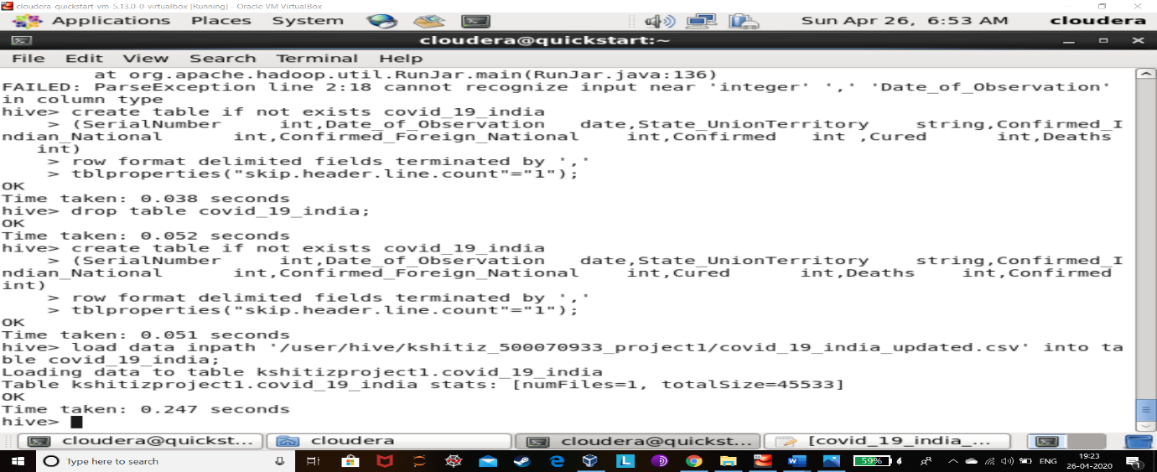 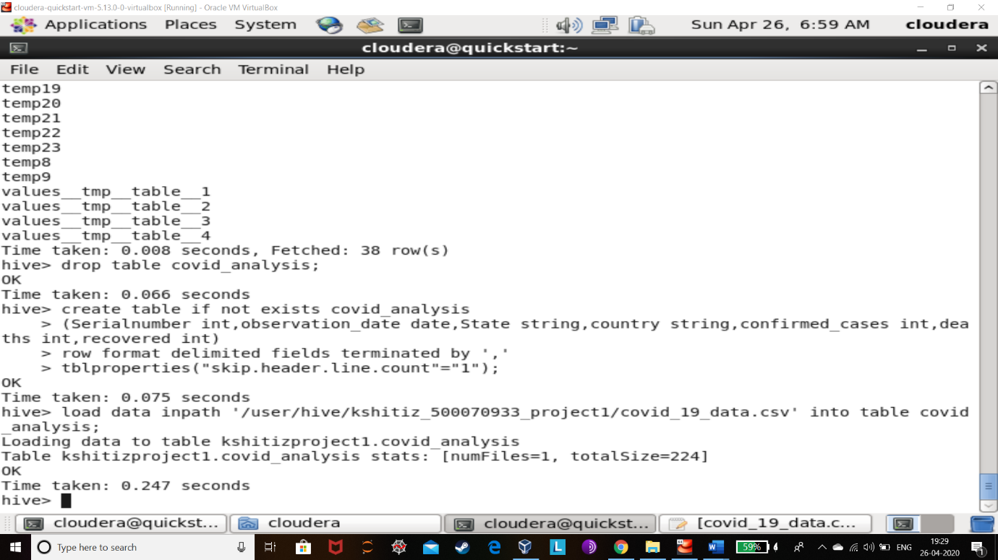

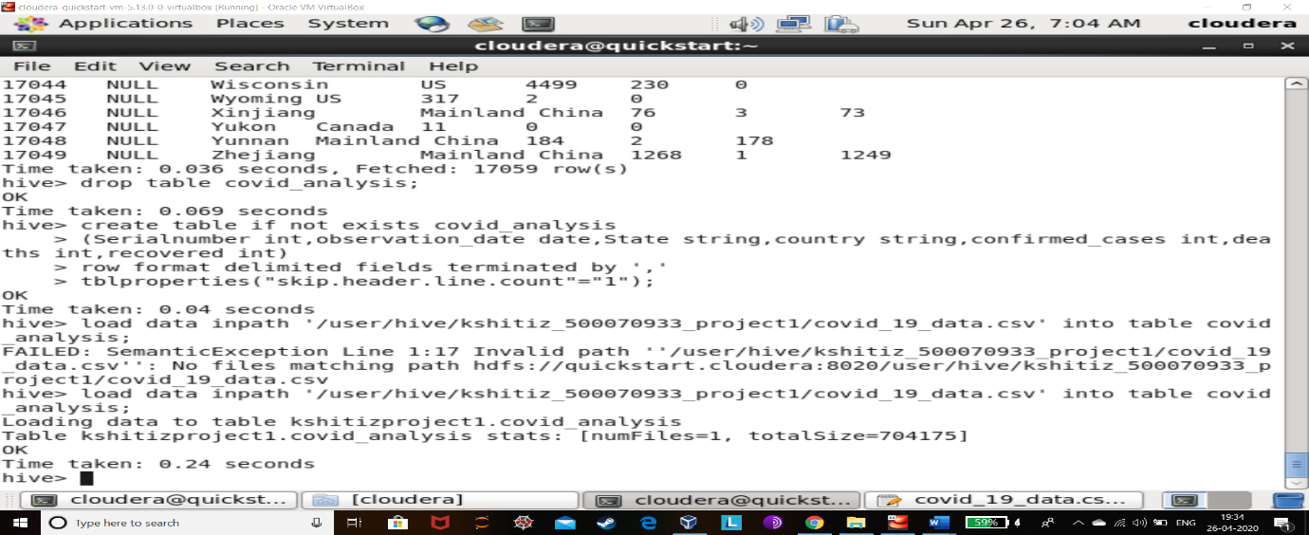 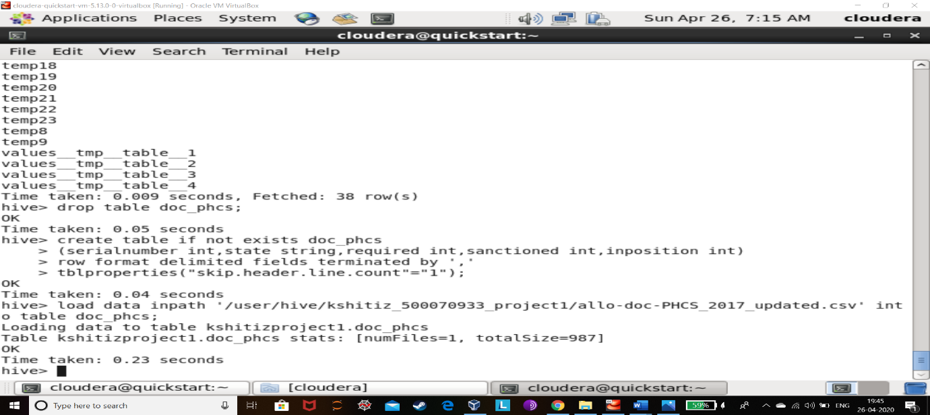 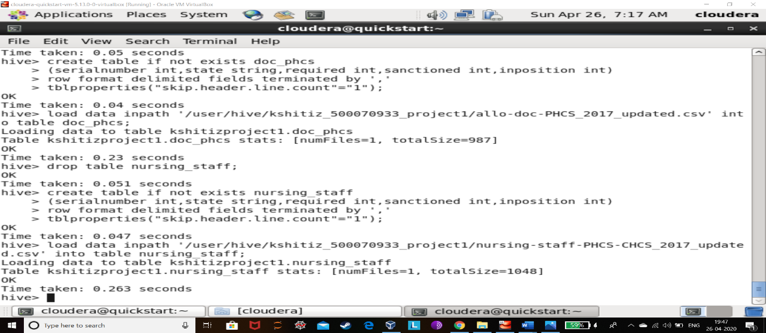

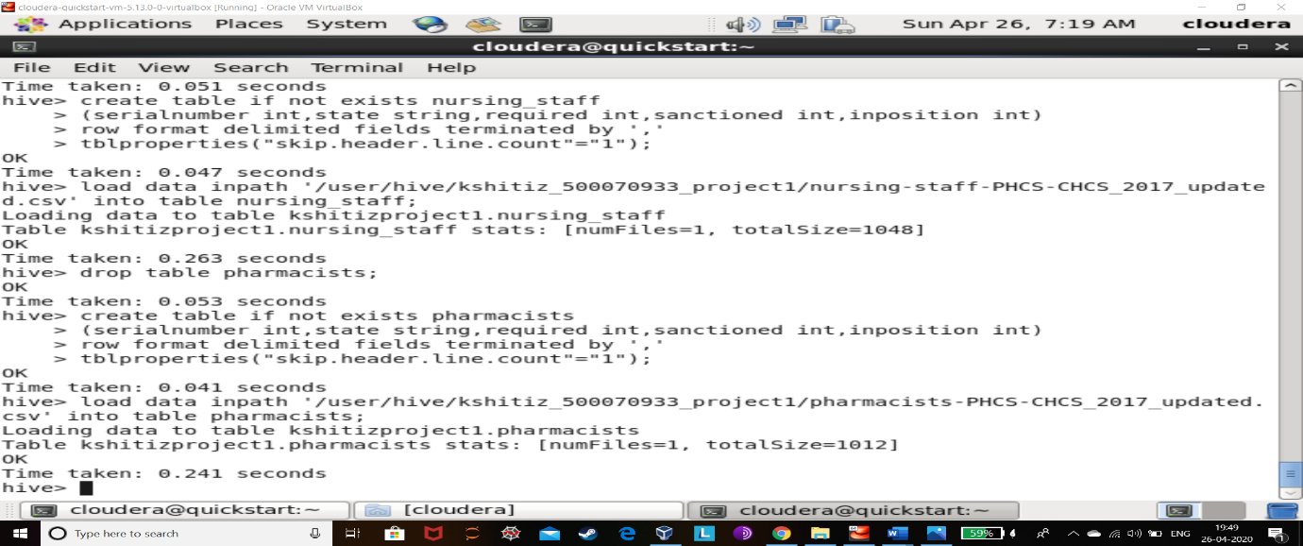 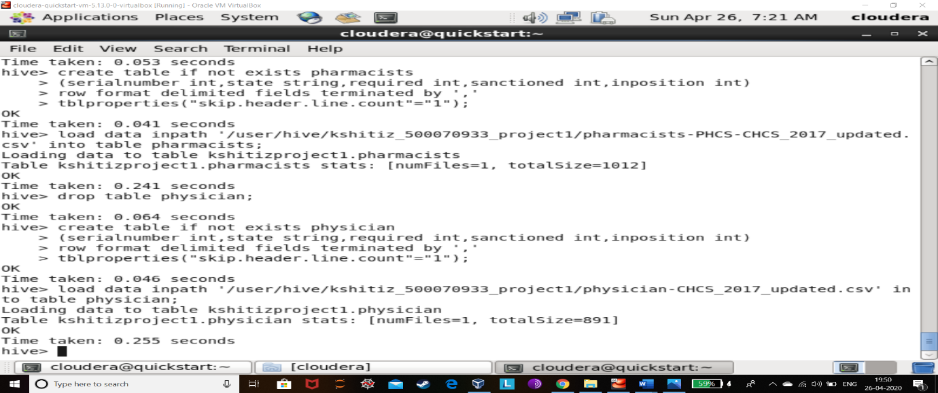 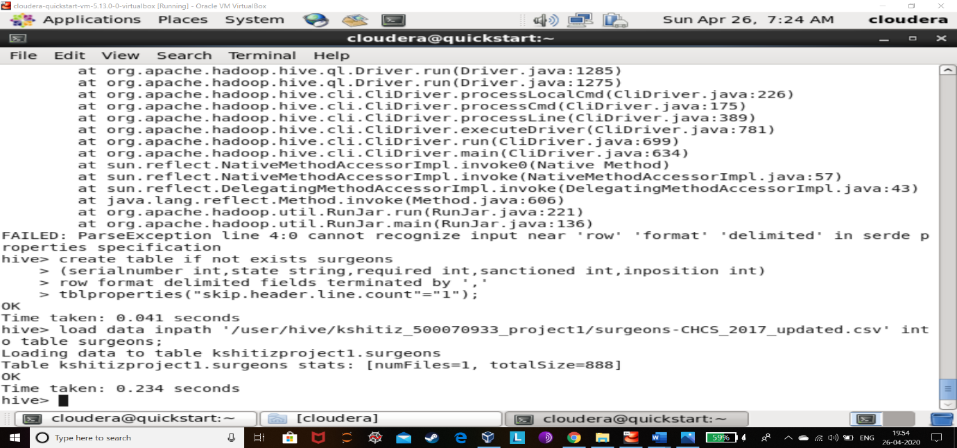 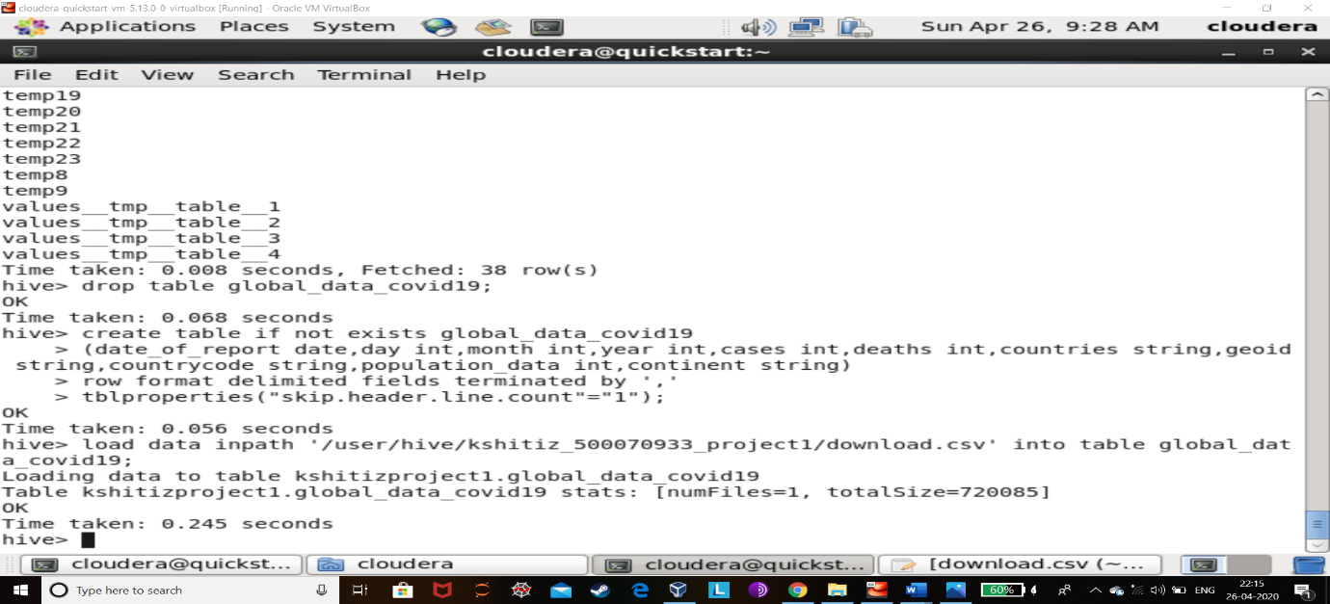 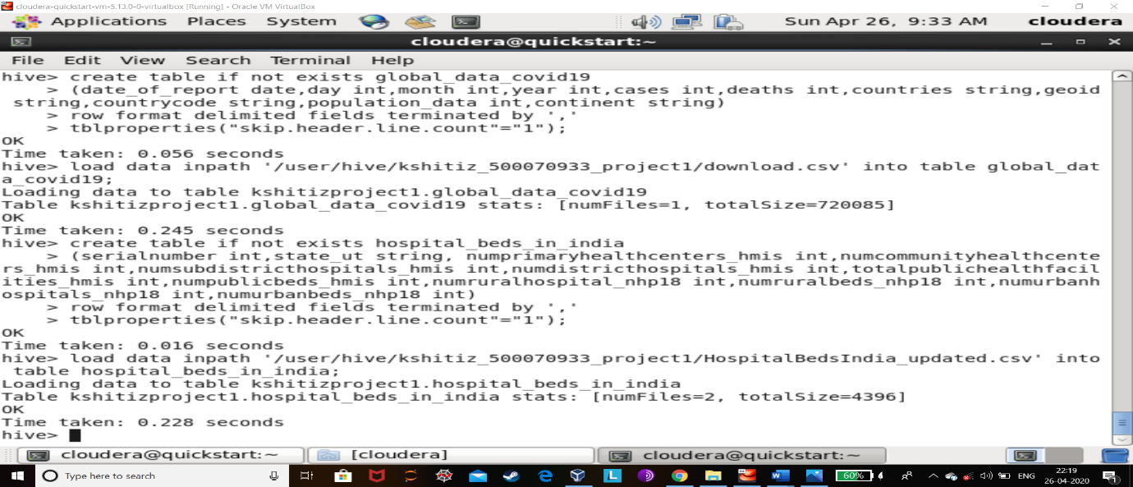 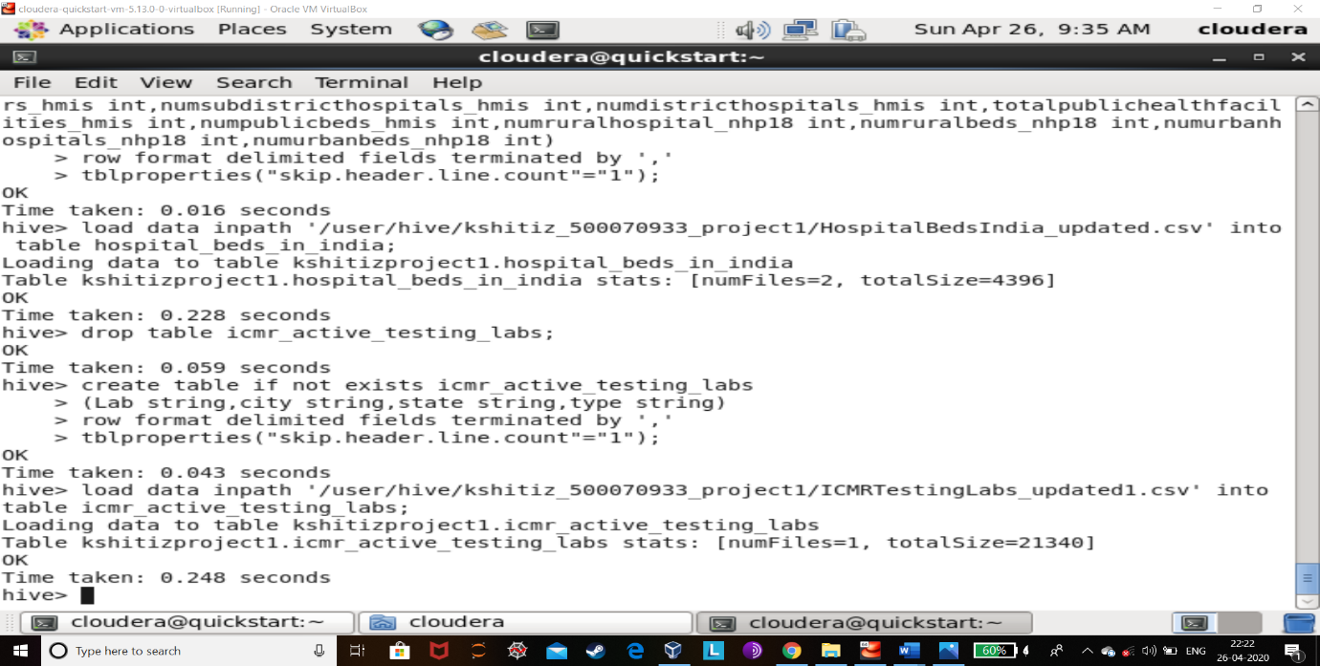 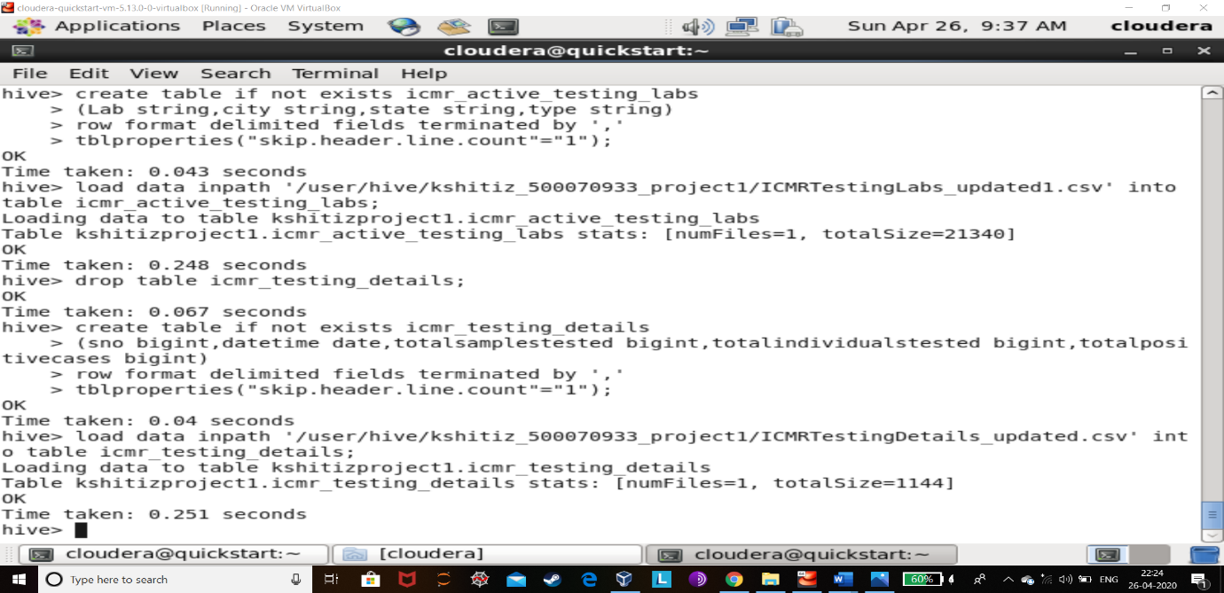 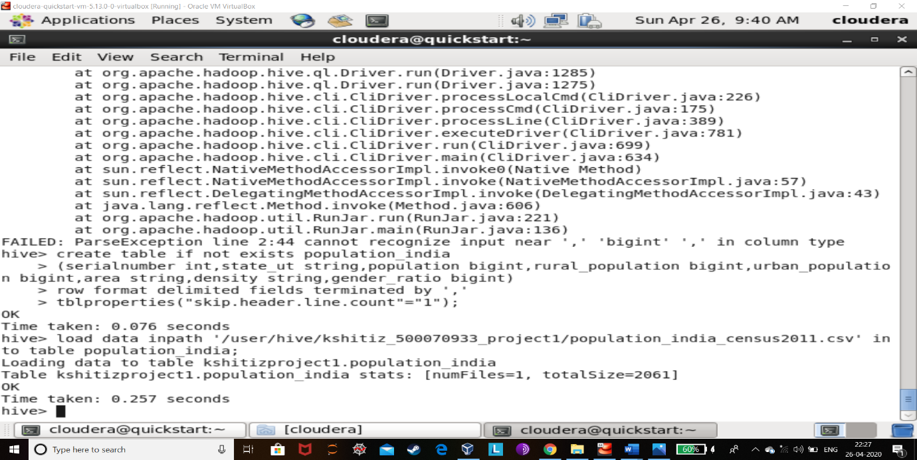 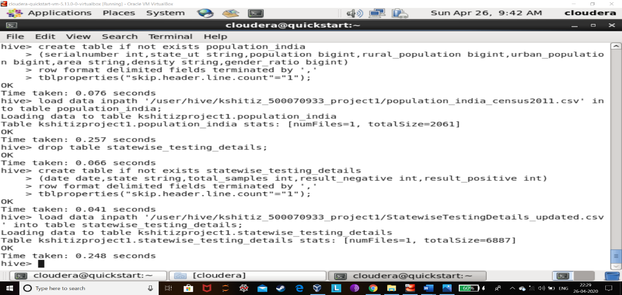

**PROBLEM 1:**

**How many beds in hospitals are going to be required internationally approximately?**

HIVE QUERY:

*select sum(cases) from global_data_covid19;*

OUTPUT:

2520522

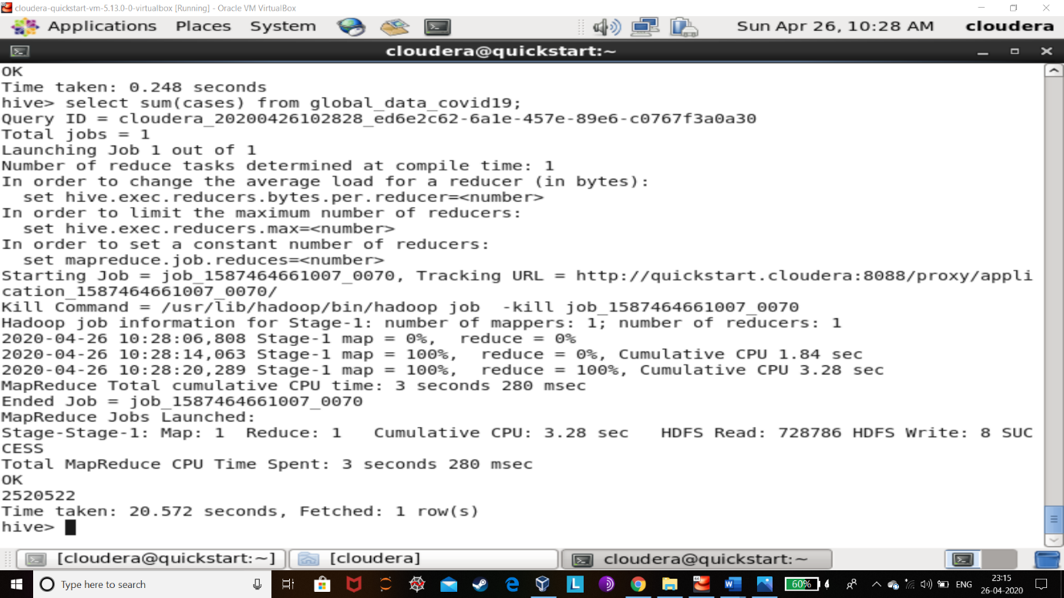

EXPLANATION:

The total beds required would be same as the cases that of the patients. There is a pandemic and we are assuming that the number of patients other than of the pandemic are much less the that cases related to coronavirus.

**PROBLEM 2:**

**How many beds in hospitals are going to be required in India approximately?**

HIVE QUERY:

*create temporary table temp5(confirmed bigint);*

*insert into temp5 select sum(result_positive) from statewise_testing_details;*

*select * from temp5;*

OUTPUT:

34532

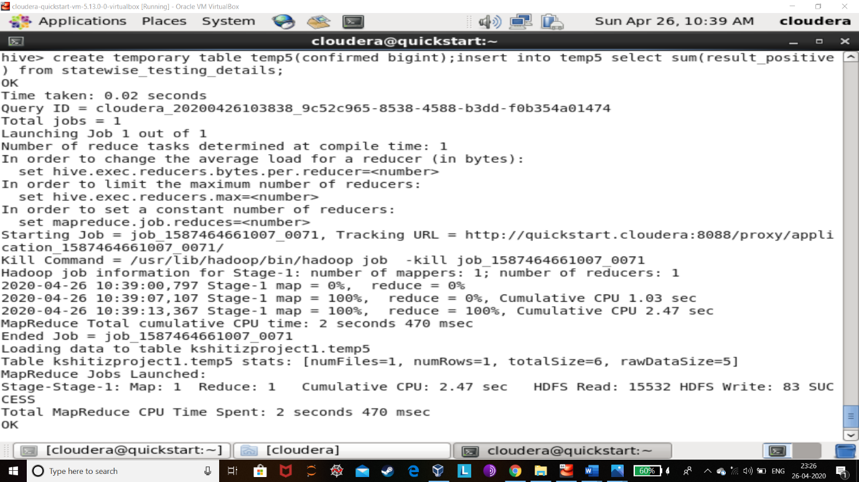

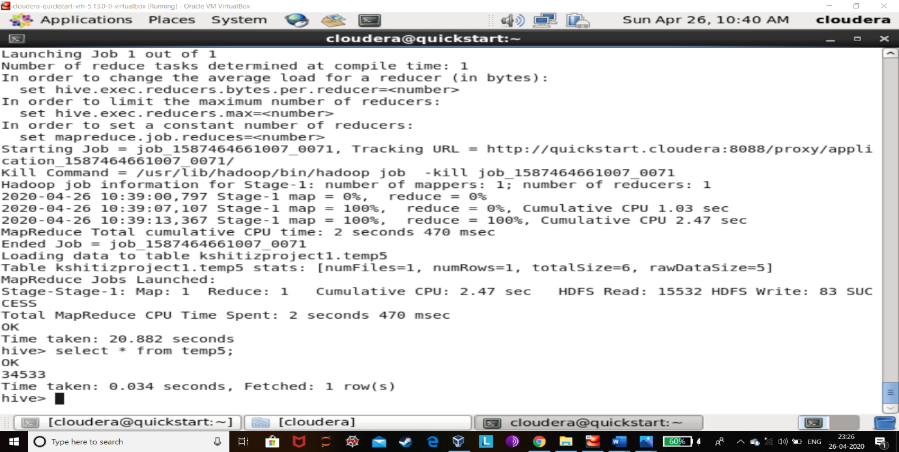

EXPLANATION:

The total beds required approximately would be same as the cases that of the patients in India. The results are totally dependent upon the data available on Kaggle.

**PROBLEM 3:**

**How many total beds are present in India to accommodate going patient number?**

HIVE QUERY:

*create temporary table temp4(total_urban_beds bigint);*

*insert into temp4 select sum(numurbanbeds_nhp18) from hospital_beds_in_india;*

*select * from temp4;*

*create temporary table temp6(total_rural_beds bigint);*

*insert into temp6 select sum(numruralbeds_nhp18) from hospital_beds_in_india;*

*select * from temp6;*

*select total_urban_beds + 279588 from temp4;*

OUTPUT:

710761

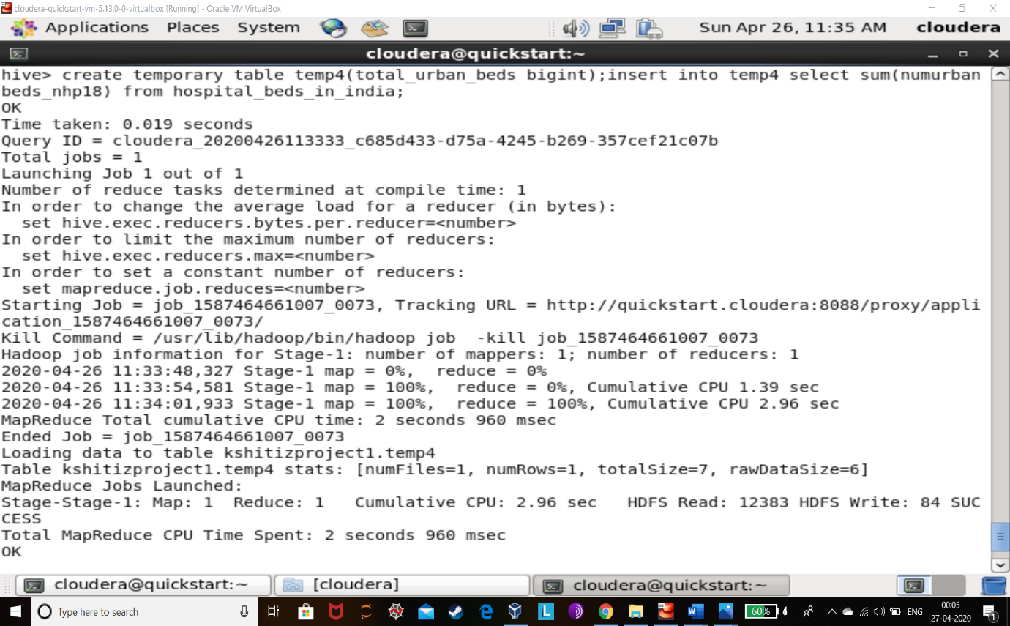

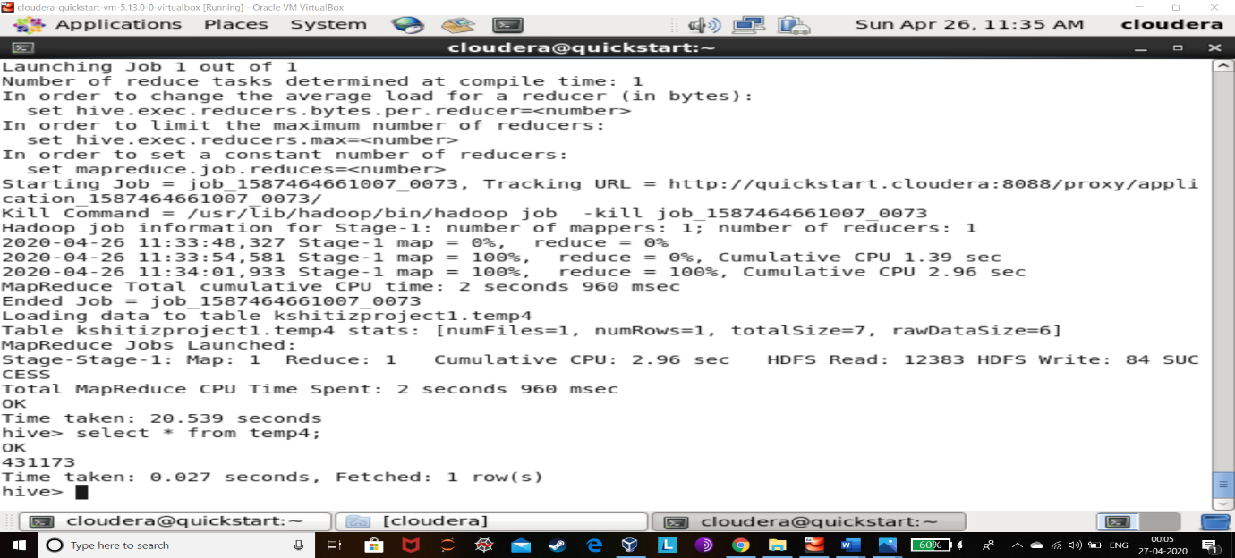

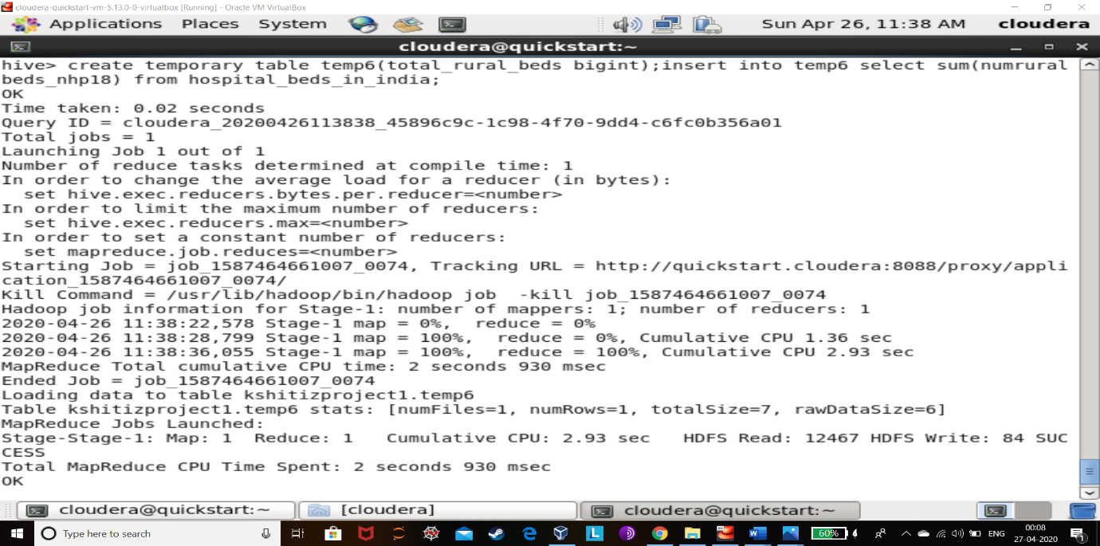 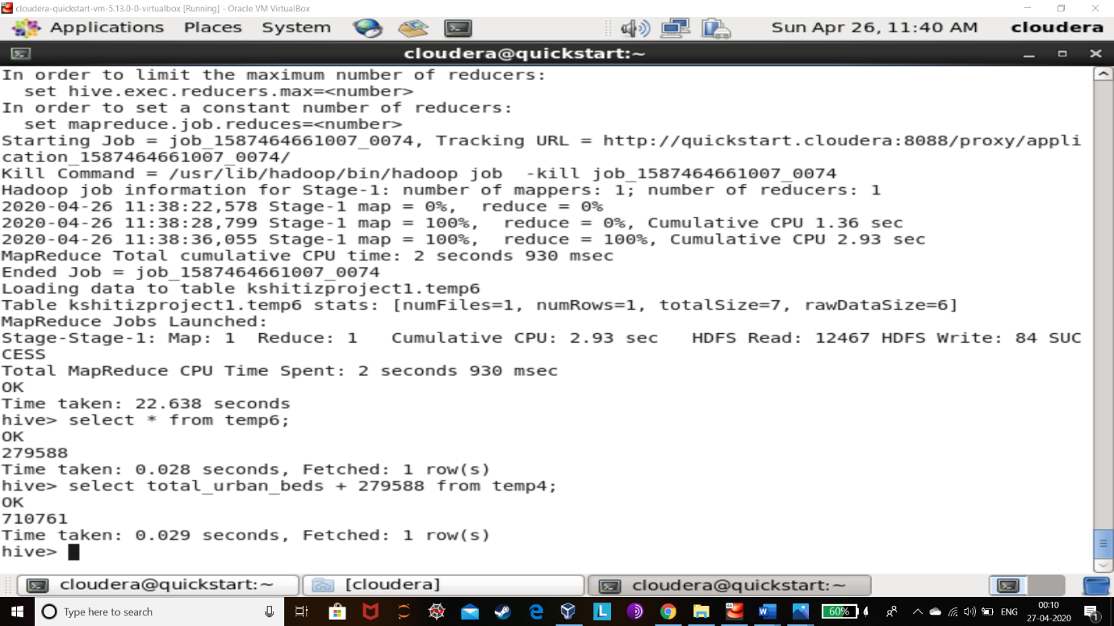

EXPLANATION:

The total number of beds that are available in India as a whole currently can be calculated by adding rural bed capacity and urban bed capacity.

This also tells us that if the number of case in India rises above 710761 then the rest of the people are most prominent to die and could also infect more people.

**PROBLEM 4:**

**How many Testing Laboratories are present in India other than Hospitals to test blood samples on large scale and to conduct research for finding a cure or vaccine for coronavirus?**

HIVE QUERY:

create temporary table temp7(total_labs int);

insert into temp7 select count(lab) from icmr_active_testing_labs;

select * from temp7;

OUTPUT:

264

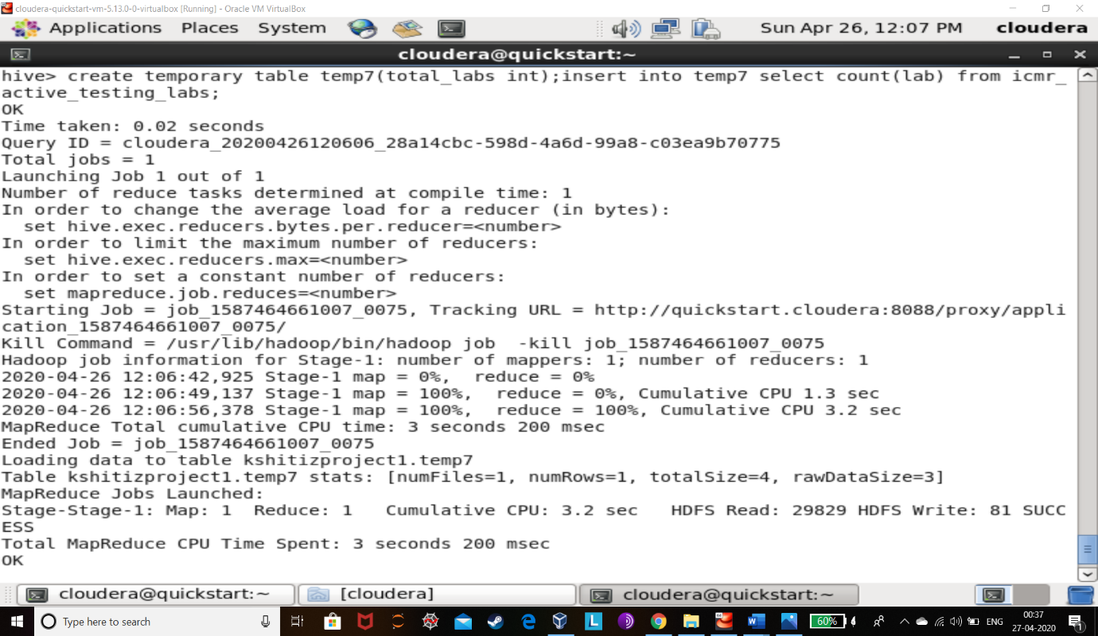

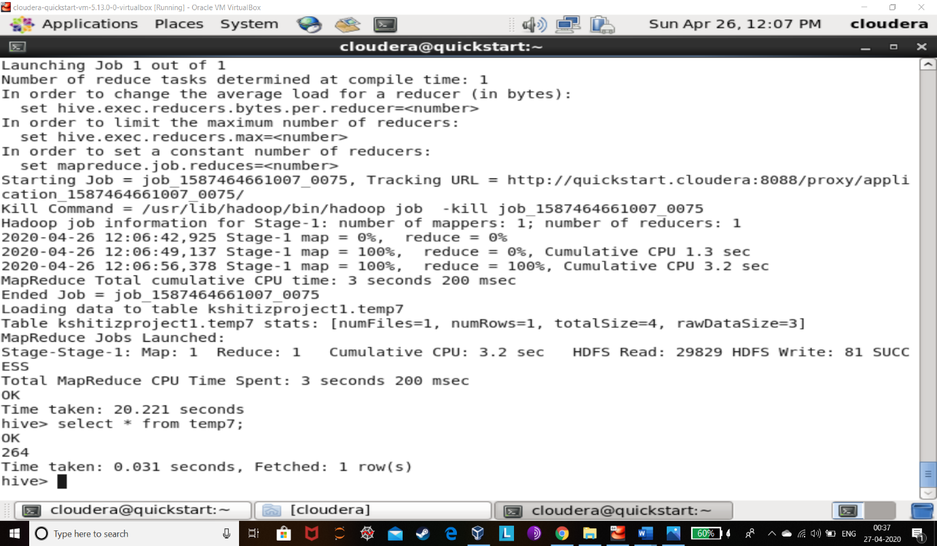

EXPLANATION:

1. To know how many laboratories are present in India I found the list of laboratories that are presently active in the coronavirus pandemic and counted the number by using count function in HIVE.
2. This tells us that India is very much behind the rest of the world in case of medical infrastructure and if this virus spreads rapidly it would be physically impossible to control.
3. This also tells that only 264 laboratories are present to conduct research and mass testing of blood samples which are being collected at every major and minor hospital.

**PROBLEM 5:**

**How many TEST KITS are required in the worst-case scenario by India to make sure who is corona positive or negative?**

HIVE QUERY:

*select sum(totalsamplestested) from icmr_testing_details;*

OUTPUT:

4240055

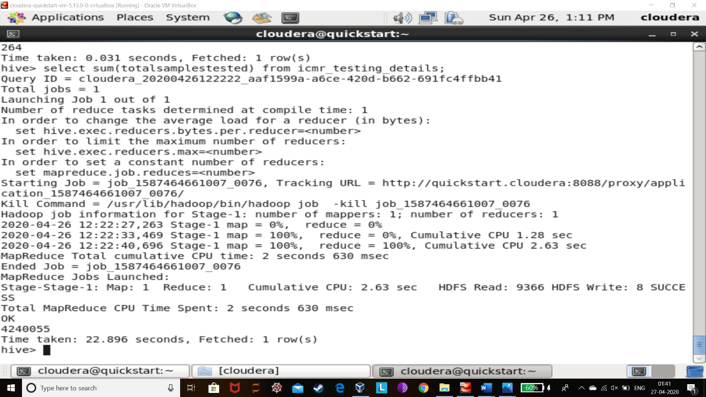

EXPLANATION:

As there is current case of complete lockdown the data that is in public domain of sample collection suggests after using the SUM FUNCTION in HIVE that 4.2 million (4240055) TEST KITS would be required by India.

This is only if the current lockdown is successful.

**PROBLEM 6:**

Who is the maximum coronavirus effected people in India?

HIVE QUERY:

*select percentage, age_group from age_group_details sort by percentage desc;*

OUTPUT:

24.86 20-29

21.1 30-39

16.18 40-49

12.86 60-69

11.13 50-59

4.05 70-79

3.9 10-19

3.18 0-9

1.45 >=80

1.3 Missing

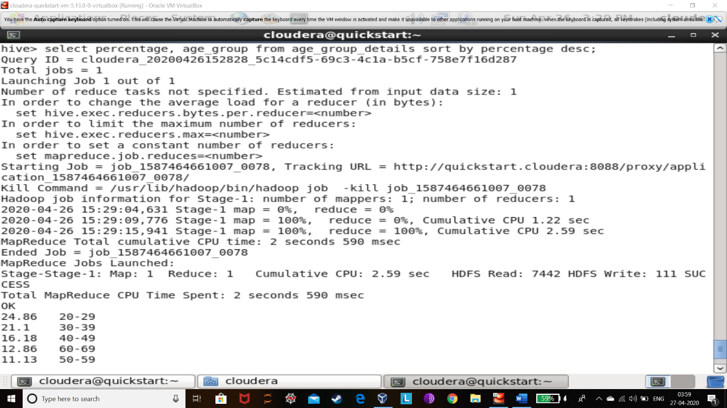 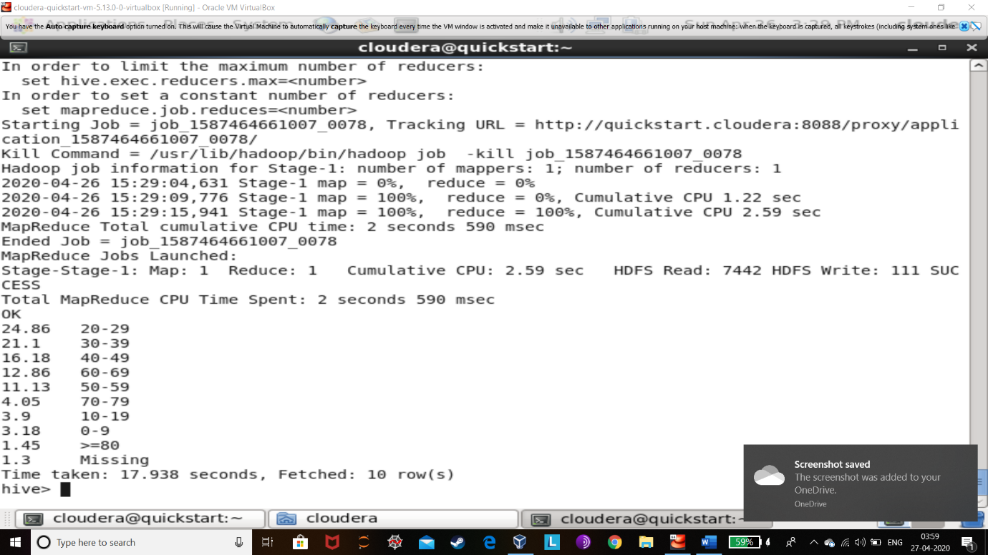

EXPLANATION:

The most effected people in India are the 20 to 29 years of age. That is also because our country’s maximum population is young people. And people who are working and travelling is also the most effected ones.

This shows that it spreads from person to person.

**PROBLEM 7:**

How many MASKS and HAND GLOVES are needed to be imported or produce in India?

HIVE QUERY:

*select sum(population) from population_india;*

OUTPUT:

1210568111

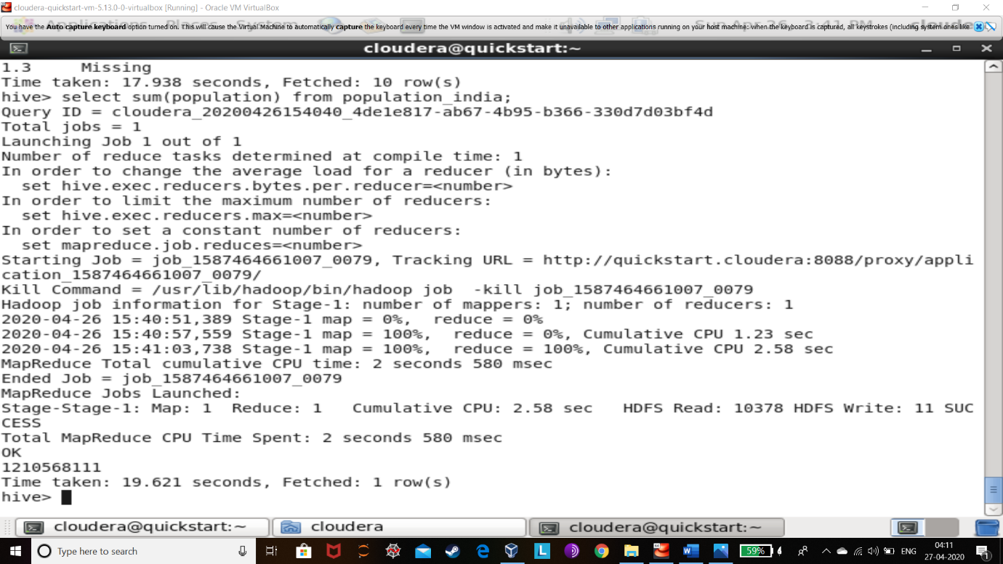

EXPLANATION:

In this I used SUM function for adding all the state-wise population.

This is important because India is a very big country and also a very big economy i.e. top 5 economies in the world and we knew that this virus spreads from person to person hence to protect people we have to buy or produce more MASKS and HAND GLOVES to distribute among people.

**PROBLEM 8:**

**What is the increase in rate of corona spread in India?**

HIVE QUERY:

*create temporary table temp16(date date,result_positive int);*

*insert into temp16 select date, result_positive from statewise_testing_details where date = '2020-03-16';*

*select * from temp16;*

*create temporary table temp17(date date,result_positive int);insert into temp17 select date, result_positive from statewise_testing_details where date = '2020-03-17';*

*select * from temp17;*

*create temporary table temp22(sum int);*

*insert into temp22 select sum(result_positive) from temp17;*

*insert into temp22 select sum(result_positive) from temp16;*

*select * from temp22;*

*select 39-35 from temp22;*

*create temporary table temp19(date date,result_positive int);*

*insert into temp19 select date, result_positive from statewise_testing_details where date = '2020-04-09';*

*create temporary table temp20(date date,result_positive int);*

*insert into temp20 select date, result_positive from statewise_testing_details where date = '2020-04-10';*

*create temporary table temp44(sum int);*

*insert into temp44 select sum(result_positive) from temp20;*

*insert into temp44 select sum(result_positive) from temp19;*

*select * from temp44;*

*select 5675-3950 from temp44;*

OUTPUT:

4 /* RATE OF SPREAD PER DAY ON DATE 2020-03-16,03-17*/

1725 /*RATE OF SPREAD PER DAY ON DATE 2020-05-09,2020-04-10*/

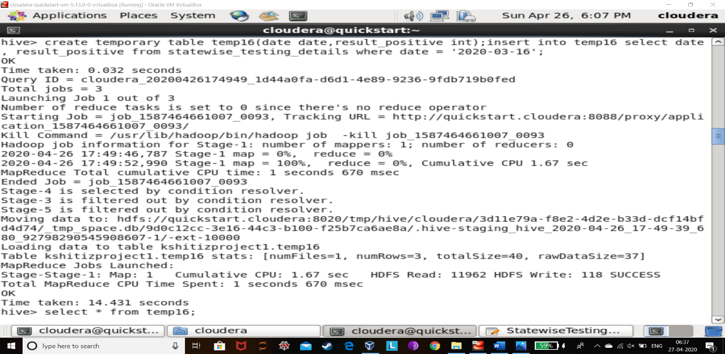

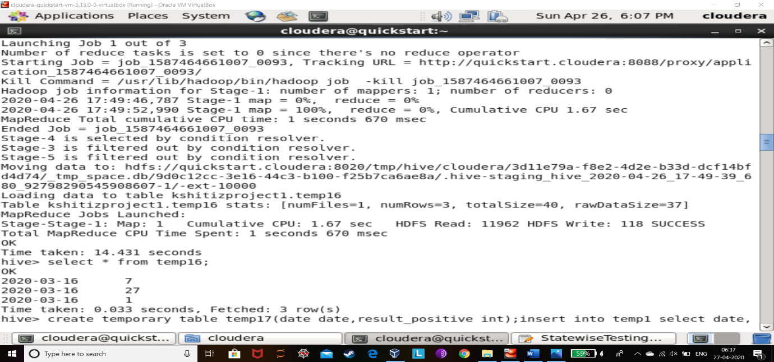

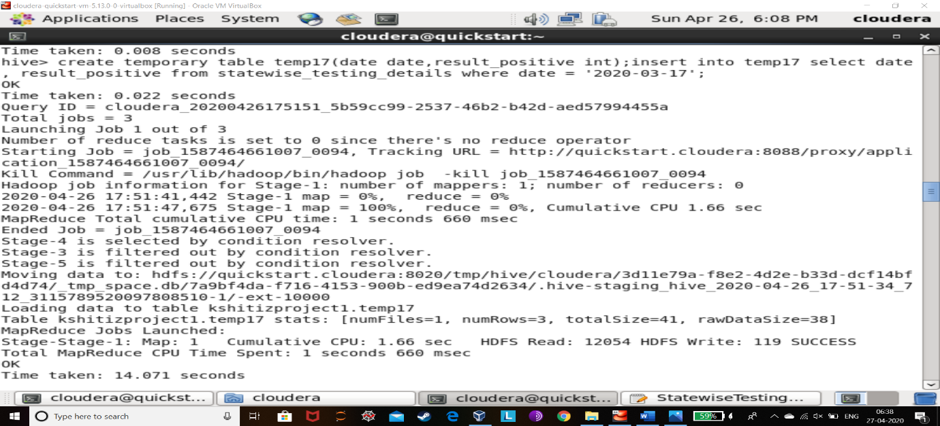

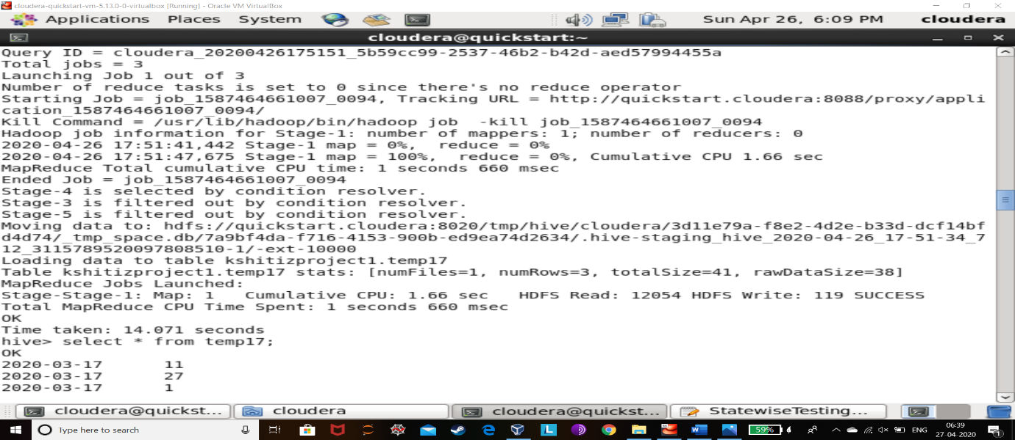

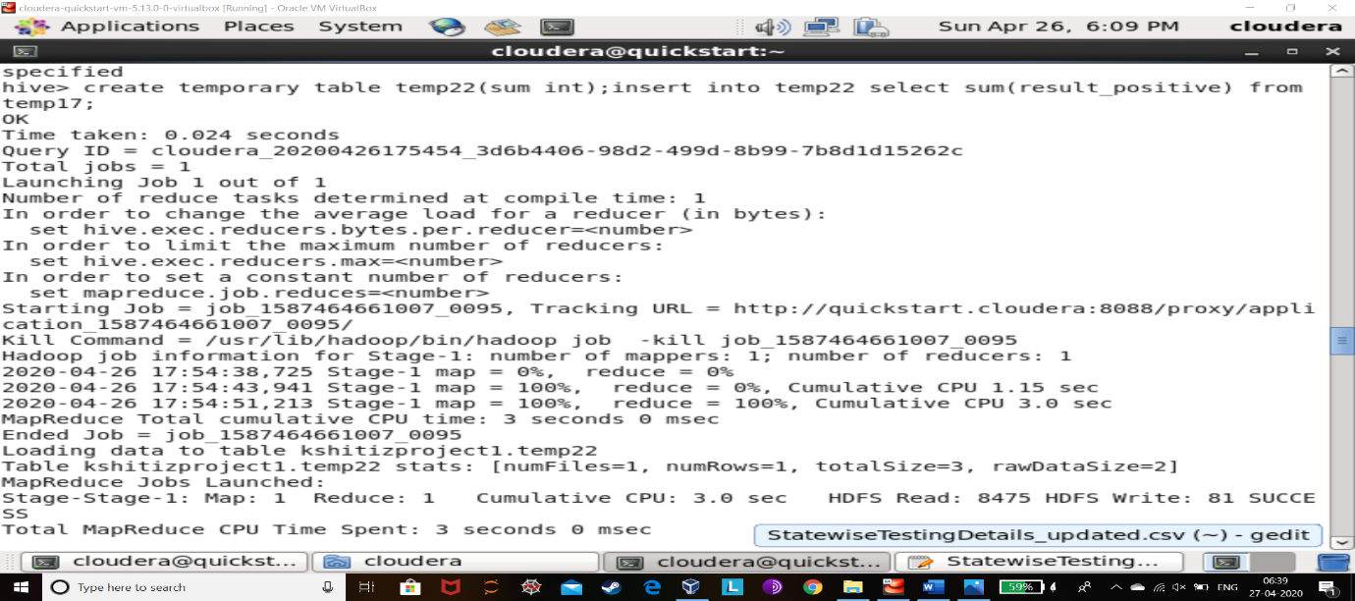

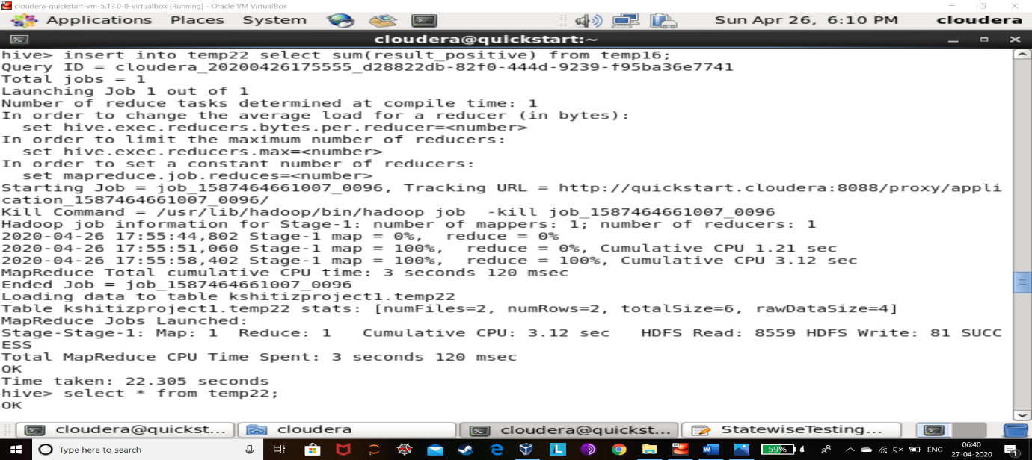

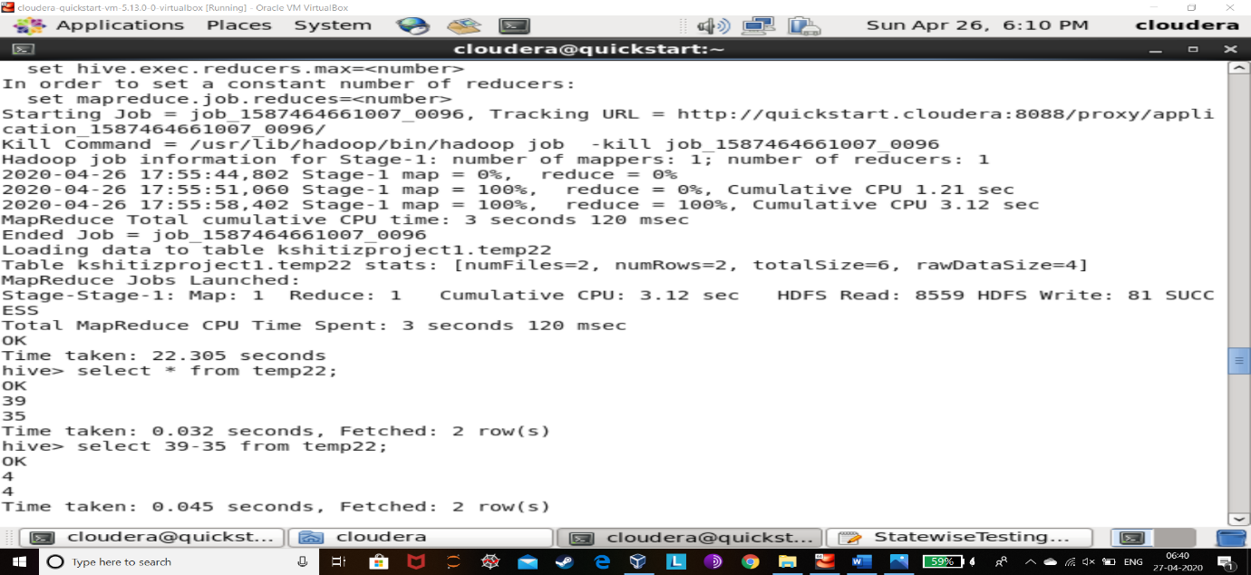

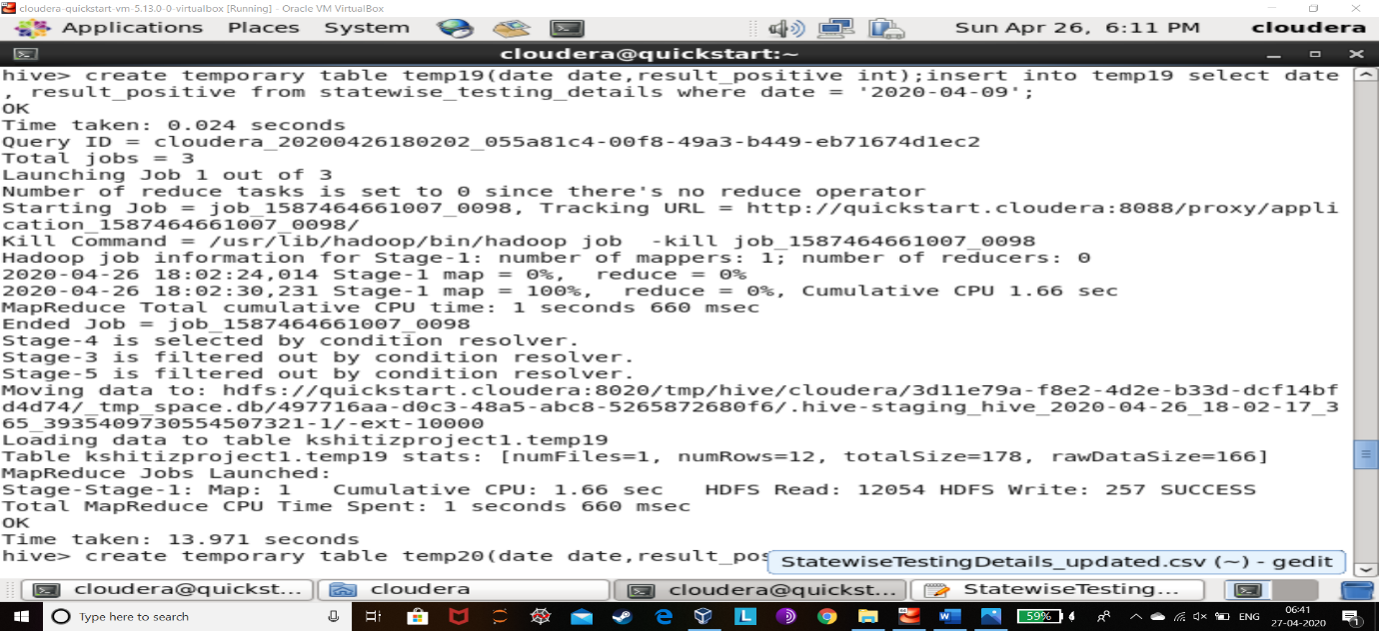

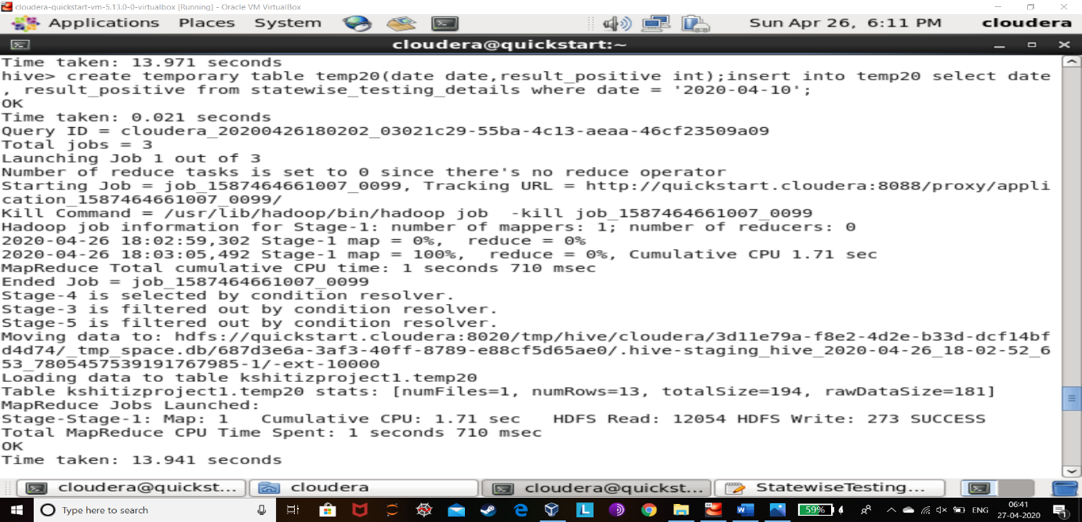

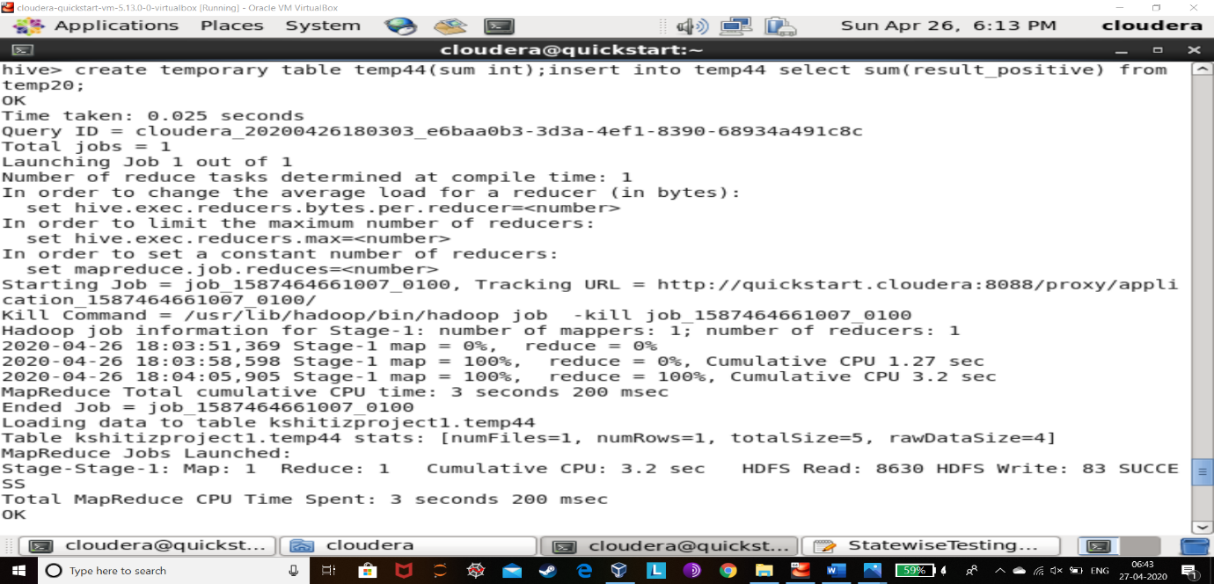

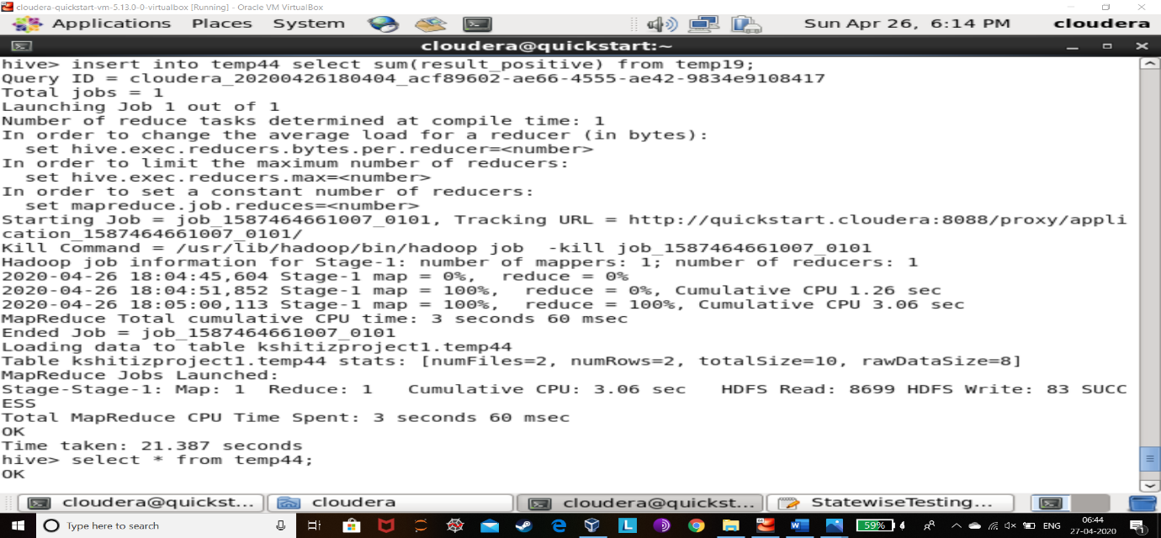

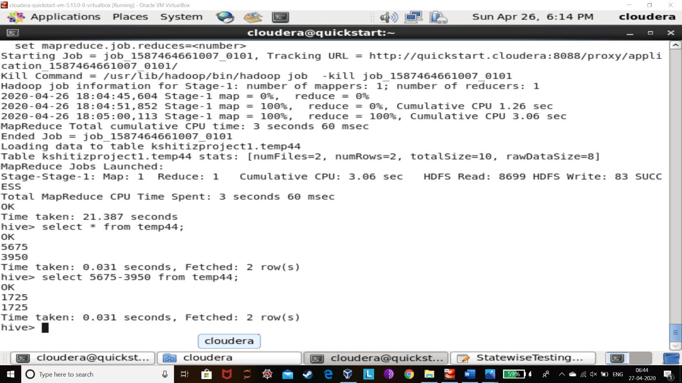

EXPLANATION:

This is the calculation of change in rate of spread (per day) of coronavirus from date 2020-03-16,2020-03-17 to 2020-04-09,2020-04-10.

As dates were already mentioned from day to day I subtracted the number of positive corona cases from two consecutive days and then did this same thing on the dates that are almost one month apart so that change in rate of spread could be shown.

As a result we can see initially only 4 corona positive cases were there but approximately one month later the data (after analysis) says there were 1725 corona positive cases.

And as we know the growth in positive corona cases is a very bad news for India.

**PROBLEM 9:**

How big is India’s MEDICAL TEAM to tackle the pandemic?

HIVE QUERY:

*create temporary table temp9(sum int);*

*insert into temp9 select sum(InPosition) from assistant_female_doc;*

*insert into temp9 select sum(InPosition) from assistant_male_doc;*

*insert into temp9 select sum(InPosition) from doc_phcs;*

*insert into temp9 select sum(InPosition) from nursing_staff;*

*insert into temp9 select sum(InPosition) from pharmacists;*

*insert into temp9 select sum(InPosition) from physician;*

*insert into temp9 select sum(InPosition) from surgeons;*

*select sum(sum) from temp9;*

OUTPUT:

151232

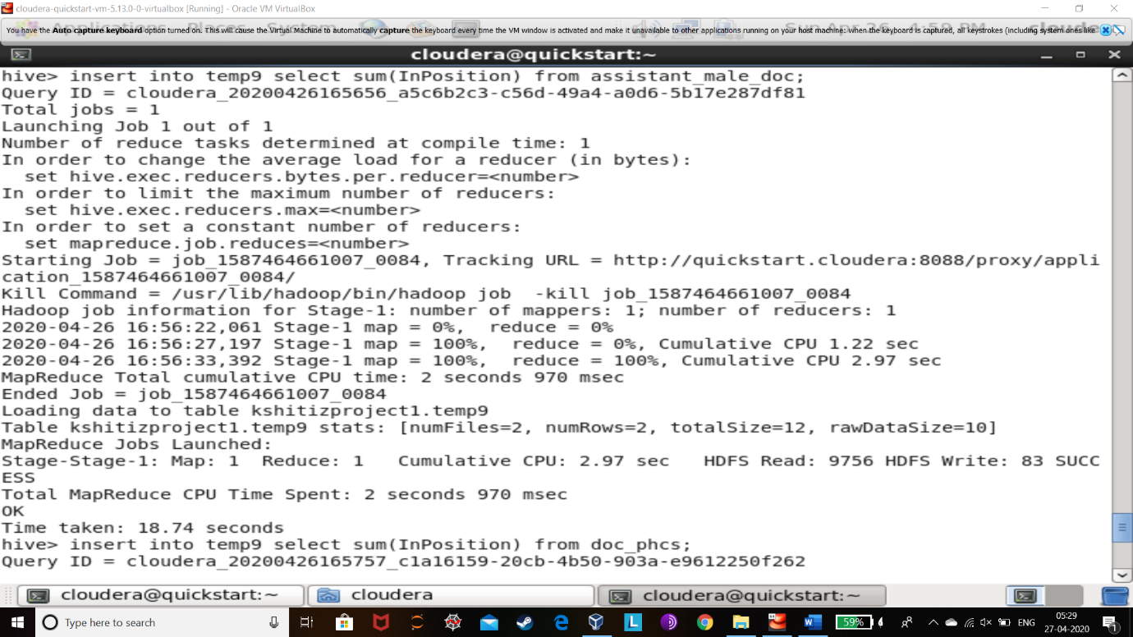

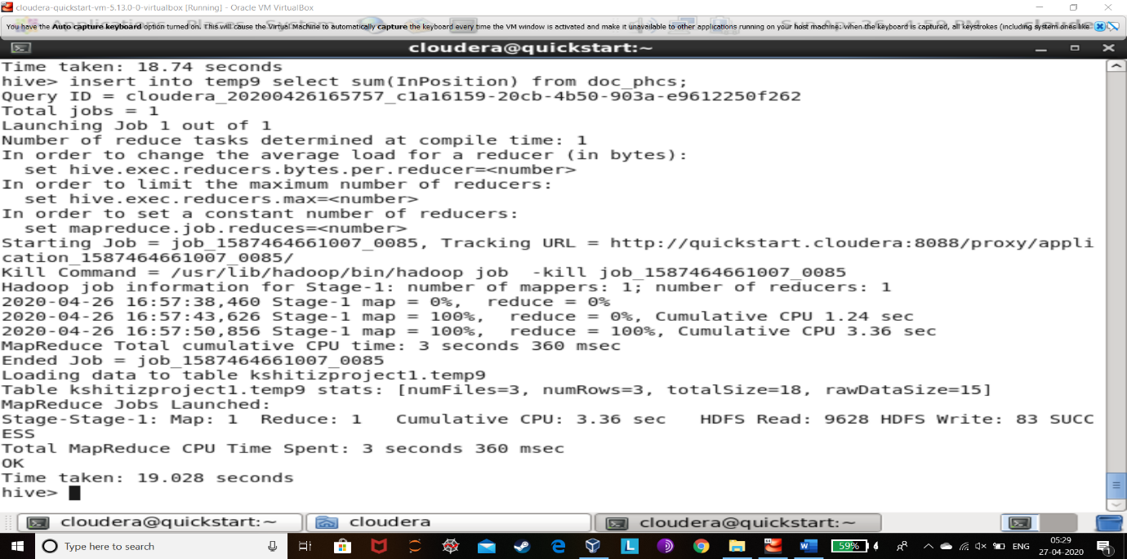

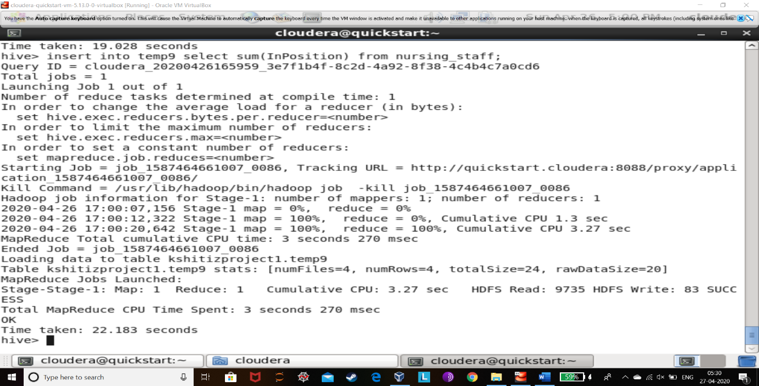

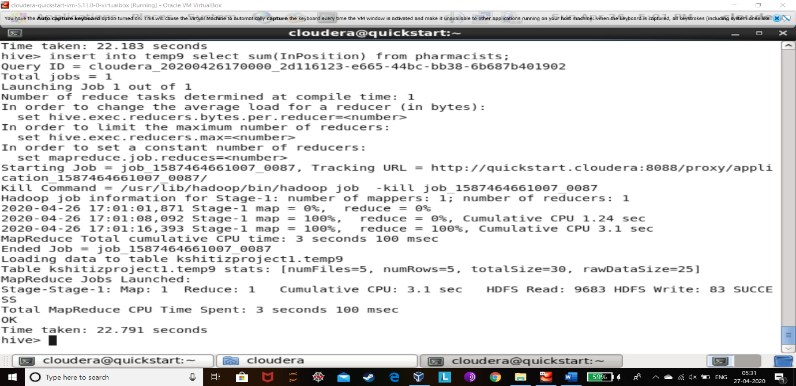

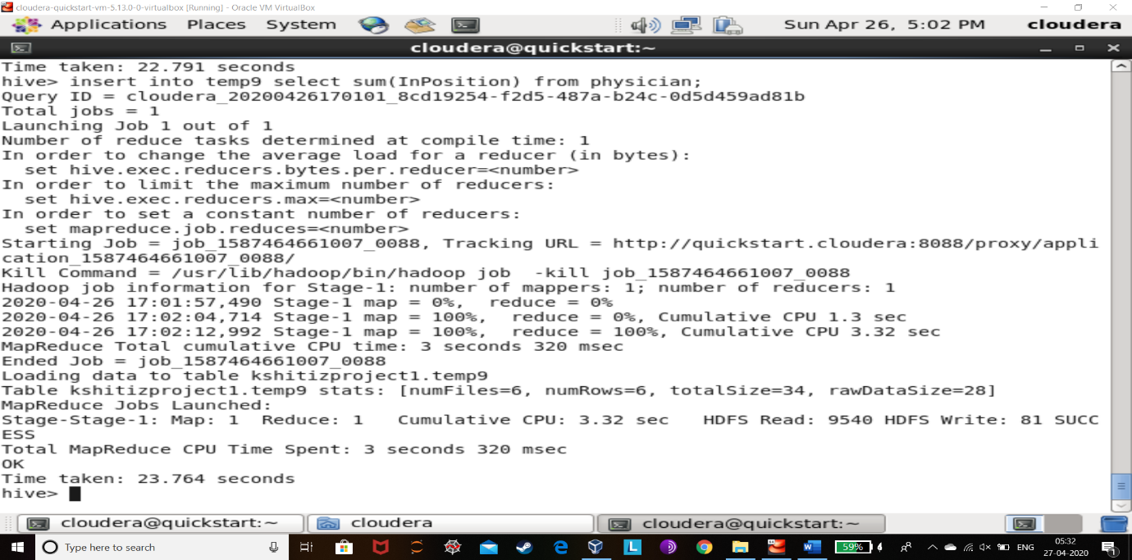

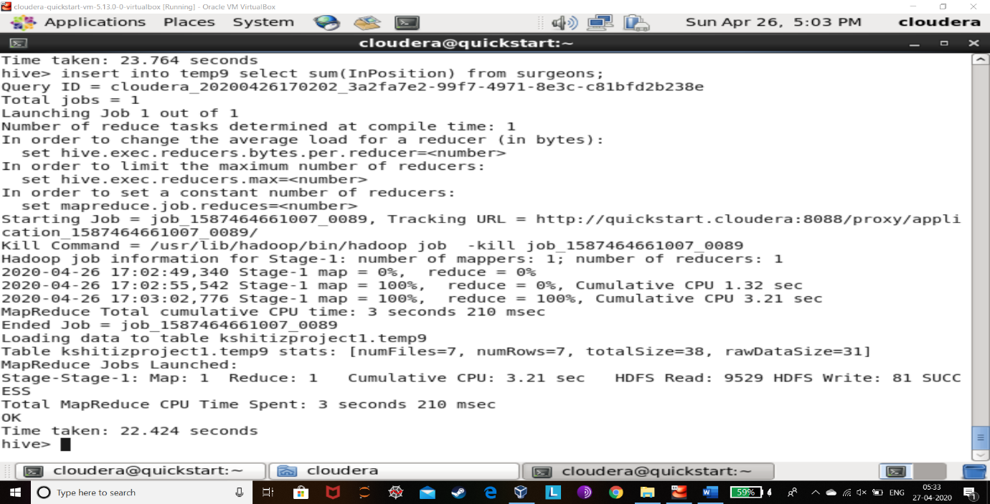

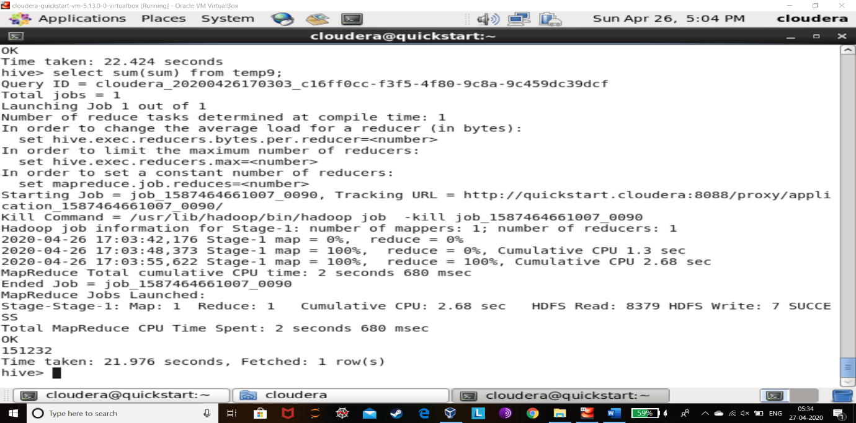

EXPLANATION:

In this I created a temporary table and stored all the summed up values of each doctor category’s “InPosition” (working doctor) number and then summed up the values of the temporary table’s value as it would give me total number of working doctors.

This analysis tells us that if the number of patients are less than 151232 then we can fight this pandemic very successfully but if it keeps on increasing then it would increase the difficulty day by day

**PROBLEM 10:**

**How to make sure that coronavirus does not spread further in the people?**

HIVE QUERY:

*create temporary table temp1(sum_population int); insert into temp1 select sum(population) from population_india;*

*create temporary table temp2(sum_population int); insert into temp2 select sum(area) from population_india;*

*select * from temp2; (3289589 Km^2)*

*select * from temp1;*

*select sum_population/3289589 from temp1;*

OUTPUT:

367.9998051428309

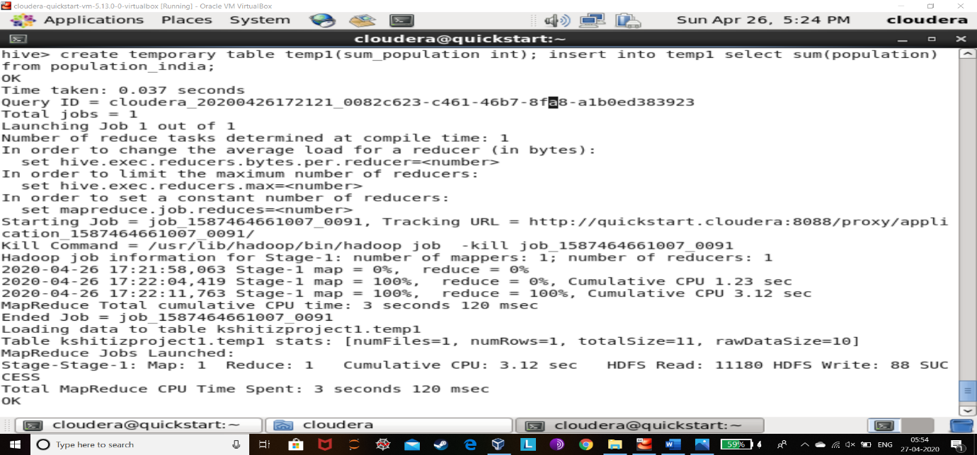

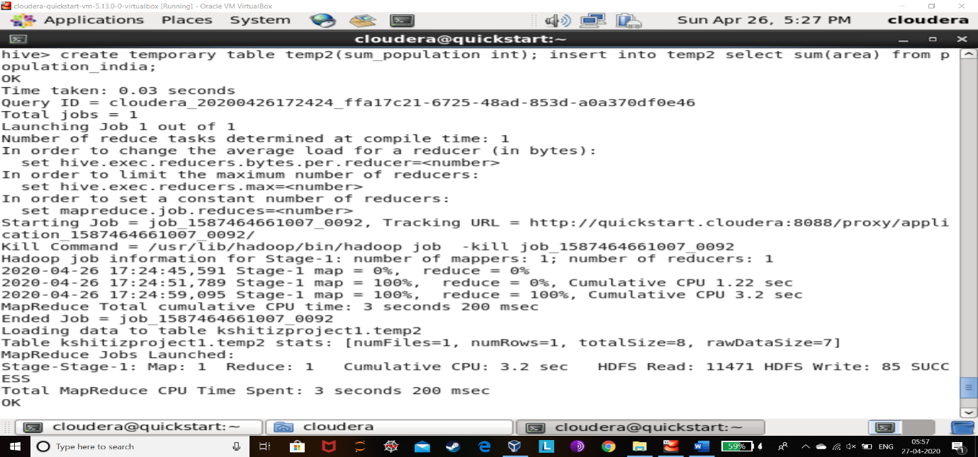

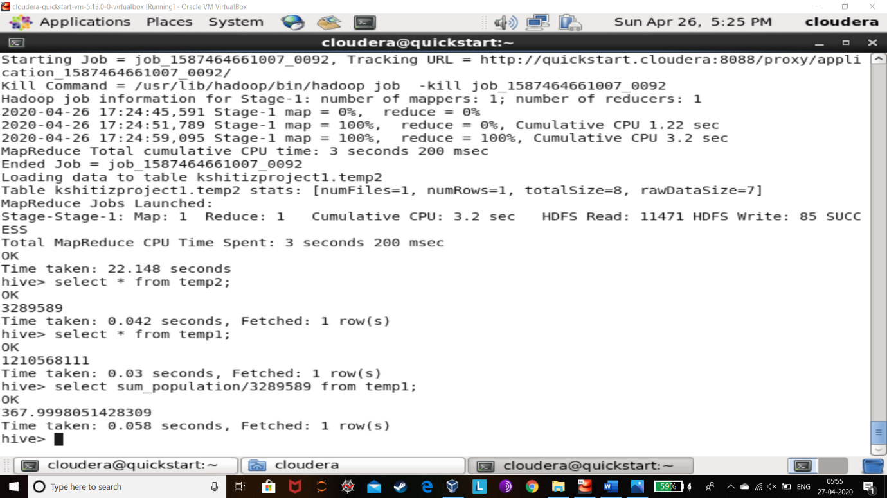

**EXPLANATION:**

Here I have divided population(number of people in India)/area(total landscape of India) which will give us the average density of people per Km^2 . And by this we could say that large groups that too more than 368 people should not be gathered at any reason in India.

This gives us information about how many people could buy essential products for there lively hood in the period of complete LOCKDOWN at a time in a region.

**As the complete Lockdown is for the benefit of people, we should follow it and respect it.**